SCIENCE 10 – CHEMISTRY – METALS AND NONMETALS
NAME: _________________________________________ DATE: December 14, 2016
Comparison of Metals to Nonmetals (page 185 #1)
PROPERTY | METALS | NONMETALS
Lustre (shiny or dull)
Malleability
Conductivity
(electricity and heat)

State at room temperature
(solid, liquid, or gas)
OTHER INFORMATION
PROPERTY | METALS | NONMETALS
Location on periodic table
(on left or right?)
Tendency to gain or lose electrons
Charges of ions formed (positive or negative)
Other properties
Any two examples (names with symbols)
BOHR-RUTHERFORD DIAGRAM
Provide the following information of the following elements (A to J below) as shown in the example below:
- Symbol of the element (letter or letters)
- Draw the Bohr-Rutherford diagram (showing value or number of the proton, neutron, and electron number (use the periodic table or textbook).
- Ionic charge of the following elements (positive or negative charge)
Example:
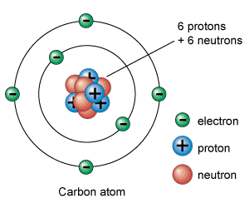
Carbon
- Symbol = C
- Bohr diagram (see diagram to right)
- Ionic charge = 4-

ON YOUR OWN PAPER INDICATE THE FOLLOWING:
- Symbol of the element (letter or letters)
- Draw the Bohr-Rutherford diagram (showing value or number of the proton, neutron, and electron number (use the periodic table or textbook).
- Ionic charge of the following elements (positive or negative charge)

- Sodium
- Magnesium
- Oxygen
- Silicon
- Helium
- Hydrogen
- Carbon
- Bromine
- Nitrogen
- Lithium

