Multiple Right Triangles Assignment – Value 80 – DECEMBER 12, 2016
Name: ___________________________________________ DUE: DECEMBER 13, 2016
tan ϴ = opposite sin ϴ = opposite cos ϴ = adjacent
adjacent hypotenuse hypotenuse

- Determine the length of x and y in each figure. Express your answers to the nearest whole number. SHOW FORMULAS AND CALCUALTIONS ON YOUR OWN PAPER – Value 40 (10 pts. each)
- (b)
25⁰
Y
35⁰
X
Y
20m

X
35⁰
15⁰

12
120
- (d)
25⁰
28⁰

62
Y

X

35⁰
X
X
36⁰

- Determine the measure of the two unknown angles in each figure. Express your answer to the nearest degree. SHOW FORMULAS AND CALCULATIONS – Value 20 (10 pts each)
(a) (b)
Ɵ₁Ɵ
Ɵ₁Ɵ
68
40
Ɵ₂Ɵ
52
22
90
45
Ɵ₂Ɵ

WORD PROBLEMS – Value 20
SHOW FORMULAS AND CALCULATION FOR EACH ON YOUR OWN PAPER
- A radio antenna is supported by two guy wires. Wire 1 is 25 ft. long and makes an angle of elevation of 40 degree with the ground. Wire 2 is attached to the ground 14 ft. from the base of the antenna and makes an angle of elevation of 52 degrees with the ground. Both wires are attached to the top of the antenna. Value 10
- Complete the diagram below with the information provided above ON YOUR OWN PAPER.
- How tall is the antenna (to the nearest foot)?

- Bill works as a bridge inspection assistant for an engineering firm in St. John’s, NL. As part of his job, he needs to continuously practice making the measurements and calculations he uses when inspecting in-service bridges.
If the deck of the bridge is cracked or unsafe, it may need to be replaced. Bill practices calculating the length of the deck.
Determine the total length of the deck needed between cable A and cable B, to the nearest meter. Value 10
32⁰
48⁰
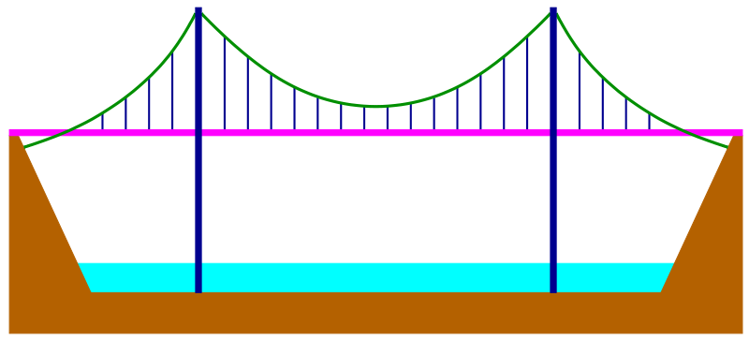
Y
X
140 m
deck
A
D
B
C

