Pythagorean Theorem Tangent Sine Cosine Ratio Test Review – November 22, 2016
NAME: _________________________________ TEST: THURSDAY, NOV 24/16
HOW TO DETERMINE WHICH TRIGONOMETRIC RATIO (FORMULA) TO USE TO CALCULATE THE VALUE OF THE UNKNOWN SIDE MEASUREMENT (X)
FORMULAS:
tan ϴ = opposite sin ϴ = opposite cos ϴ = adjacent adjacent hypotenuse hypotenuse
Identify (name) the TWO SIDES (the two sides with either with a value or an X) in each of the following right triangles below (as either opposite, adjacent, hypotenuse)
The two sides identified in each diagram below will determine the formula to use.
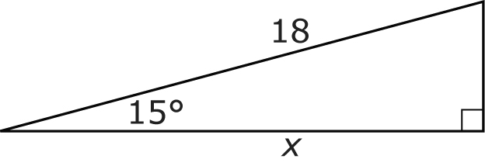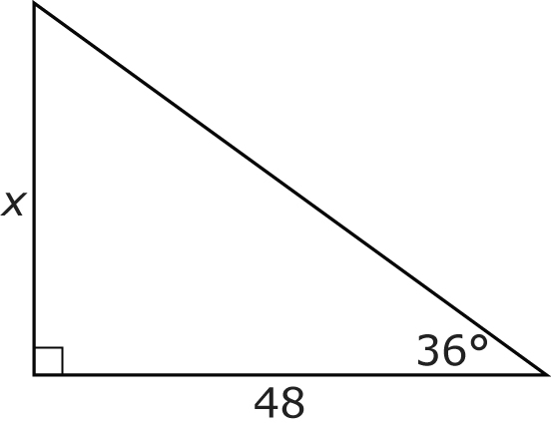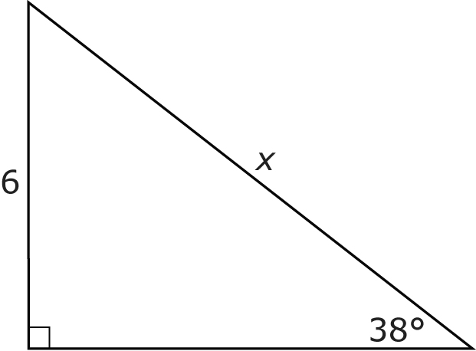
angle measurement = ______
___________ side = _______
____________ side = _______
angle measurement = ______
___________ side = _______
____________ side = _______
angle measurement = ______
___________ side = _______
____________ side = _______

FORMULA: FORMULA: FORMULA:

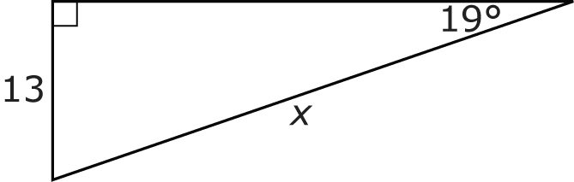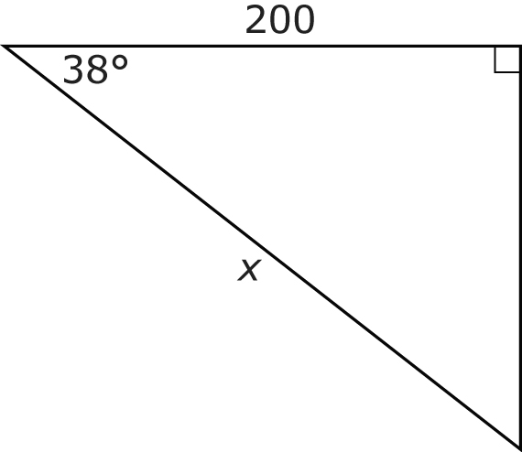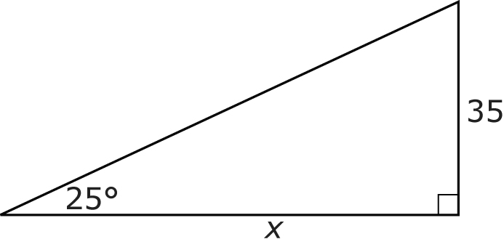
angle measurement = ______
___________ side = _______
____________ side = _______
angle measurement = ______
___________ side = _______
____________ side = _______
angle measurement = ______
___________ side = _______
____________ side = _______

TEST REVIEW PRACTICE QUESTIONS
- Multiple Choice – Circle one correct answer for each of the following.

- TRUE or FALSE – Indicate whether the following statement are true or false. Value 5
(a) ( TRUE / FALSE ) The three angles of a right triangle add up to 160 degrees.
(b) ( TRUE / FALSE ) The two sides (opposite side and adjacent side) make up the 90 degree angle of a right triangle.
(c) ( TRUE / FALSE ) Another term for hypotenuse side of a right triangle is slant or slope.
(d) ( TRUE / FALSE ) The longest side of a right triangle is the opposite side.
(e) ( TRUE / FALSE ) The longest side of a right triangle is the hypotenuse side.
- Tangent, Sine, and Cosine Ratio
- Using the right triangles below: Value 18
- First, note each of the following sides are marked as a measurement (units) or the letter (X).
- then, determine which of the following formulas to use according to the information provided.
- and last, determine the value of the unknown side measure to the nearest whole number.

FORMULAS:
tan ϴ = opposite sin ϴ = opposite cos ϴ = adjacent
adjacent hypotenuse hypotenuse

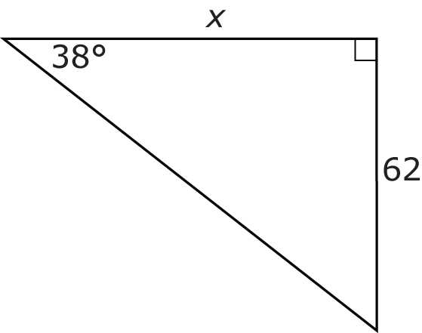
Angle measurement = ________ FORMULA:
_____________ side = __________
_____________side = __________

Angle measurement = ________ FORMULA:
_____________ side = __________
_____________side = __________
B.
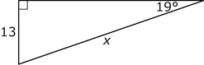
tan ϴ = opposite sin ϴ = opposite cos ϴ = adjacent
adjacent hypotenuse hypotenuse
C.
Angle measurement = ________ FORMULA:
_____________ side = __________
_____________side = __________
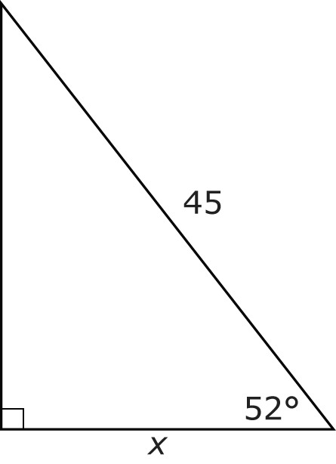

- A guy wire that is 40 m long supports a tower and forms an angle of 35° with the ground. How far is the tower base from the guy wire attachment on the ground, to the nearest meter?
- Label the diagram below with the information provided.
- Determine which formula to use based on the information provided.
- Solve for the missing value in the question.
Angle measurement = ________ FORMULA:
_____________ side = __________
_____________side = __________

- Using the right triangle below, MNO, label the diagram as indicated below:
a. Indicate ∠N as the right angle (90 degree angle).
b. Label side MN as 40 meters.
c. Label ∠M as 25 degrees.
d. Label the hypotenuse side or side MO as X.
e. Determine which formula should be used to determine the value of X.
M
Angle measurement = ________ FORMULA:
_____________ side = __________
_____________side = __________

N

O

- Using right triangles below, determine the hypotenuse side or c² for each triangle below.
a² + b² = c²

- (c)
12 m

25 ft
Side C (hypotenuse)
Side C (hypotenuse)

15 ft
16 m

a² + b² = c² a² + b² = c²

- Calculate the value of side A or side B in the right triangles below. NOTE: All triangles have the hypotenuse provided = C².

- (b)
Side C (hypotenuse) = 30 km
Side C (hypotenuse) = 40 m
20 km
A

B
28 m

a² + b² = c² a² + b² = c²

QUESTIONS WILL BE REVIEWED ON WEDNESDAY TO PREPARE FOR THURSDAYS TEST - NOVEMBER 24, 2016

