Tangent, Sine, and Cosine Ratio Assignment - Value 60 DATE: November 21, 2016
NAME: _____________________________________ DUE: NOVEMBER 21, 2016
- Multiple Choice – Circle one correct answer for each of the following. Value 5

- The three interior angles of a right triangle angles add up to __________ degrees.
- 90 degrees
- 120 degrees
- 160 degrees
- 180 degrees

- Which two sides make up the 90 degrees angle of a right triangle?
- Hypotenuse and opposite side
- Adjacent and hypotenuse side
- Opposite and adjacent side

- Other terms for hypotenuse side of a right triangle include all of the following EXCEPT:
- Slant
- Steepness
- Horizontal
- Slope

- The longest side of a right triangle is the:
- opposite side
- adjacent side
- hypotenuse side

- From the diagram below, indicate the adjacent side of the right triangle.
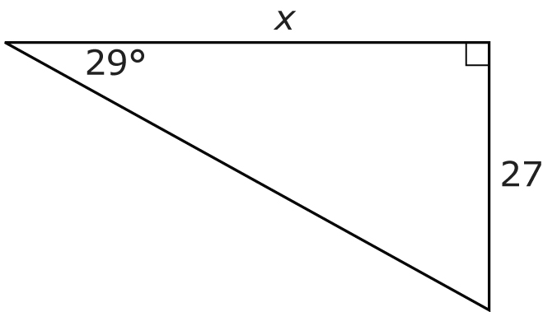
44 m
- 27
- X
- 29 degrees
- 44 m

- Tangent, Sine, and Cosine Ratios
- Using the formulas provided below to determine the value of “X” in each right triangle below.
FIRST: Use the right triangles below to determine the opposite and adjacent sides. Value 2 | Then calculate the tangent ratio and round off to the nearest tenth (of the unit indicated). Value 4
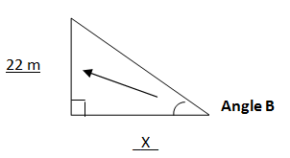  Angle B = 28 degrees  opposite = ______________  adjacent = ______________ | tan ϴ = opposite  adjacent
FIRST: Use the right triangles below to determine the opposite and hypotenuse sides. Value 2 | Then calculate the sine ratio and round off to the nearest tenth (of the unit indicated). Value 4
_X_  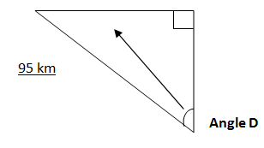  Angle D = 36 degrees  opposite = __________________  hypotenuse = ________________ | sin ϴ = opposite  hypotenuse
FIRST: Use the right triangles below to determine the adjacent and hypotenuse side. Value 2 | Then calculate the cosine ratio and round off to the nearest tenth (of the unit indicated). Value 4
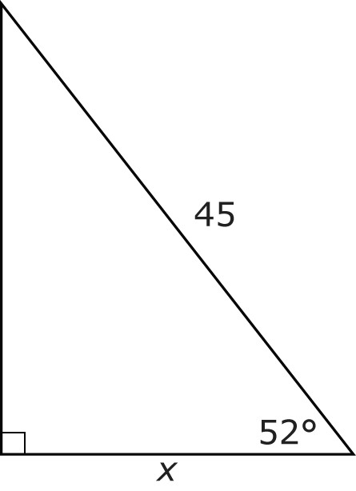  Angle A  Angle A = 52 degrees  adjacent = __________________  hypotenuse = ________________ | cosine ϴ = adjacent  hypotenuse
- Using the right triangles below: Value 18
- First identify each of the following sides (the sides that are marked as a measurement AND the letter X)
- then, determine which of the following formulas to use to determine the unknown side (or X) for each
- and last, determine the value of the unknown side measure to the nearest whole number.
FORMULAS:
tan ϴ = opposite sin ϴ = opposite cos ϴ = adjacent
adjacent hypotenuse hypotenuse
A
Angle measurement = ____________
__________ side = ______________
__________ side = ______________
FORMULA:

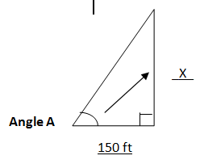
50 degrees
ANS: ________________
Angle measurement = ____________
__________ side = ______________
__________ side = ______________
FORMULA:
B
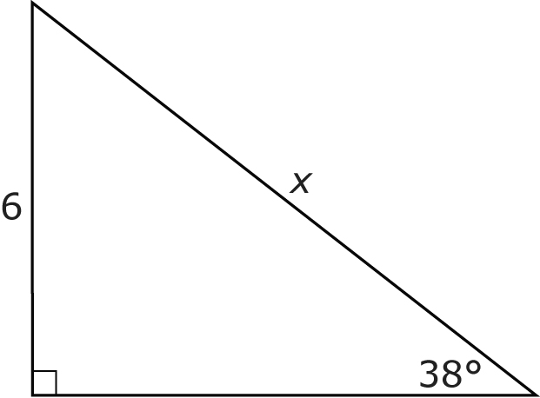
C.
ANS: __________________
Angle measurement = ____________
__________ side = ______________
__________ side = ______________
FORMULA:
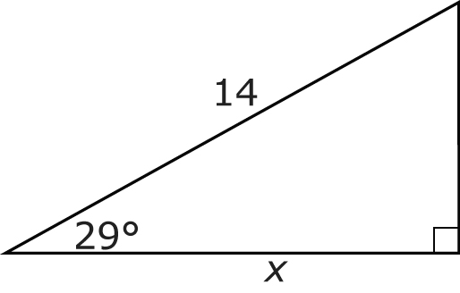
ANS: _________________
WORD PROBLEMS
- Label the right triangle below, MNO, where
- Angle N or ∠N is the right angle (90⁰) below. Value 2
b. Label side MN as 28 meters. Value 1
c. Label ∠O as 32 degrees. Value 1
d. Label the hypotenuse side (MO) as X. Value 1
e. Determine (from the information provided) which formula should be used to determine the value of X. Value 2
f. Using the formula to solve for X to the nearest meter. Value 5
Angle measurement = ____________
__________ side = ______________
__________ side = ______________
FORMULA:

ANS: ______________________

- A guy wire that is 30 m long supports a tower and forms an angle of 75° with the ground. How far is the tower base from the guy wire attachment on the ground, to the nearest tenth of a metre?
- Draw a diagram of the information provided first. Value 3
- Label the diagram with the information provided. Value 3
- Determine which formula to use based on the information provided. Value 2
- Solve for the missing value in the question. Value 5

TOTAL VALUE 60

