SCIENCE 9 – ANIMAL VS PLANT CELL CYCLE – October 17, 2016 Name: ________________
PART A - Below are pictorial representations of the phases of an animal cell cycle including interphase and cell division (mitosis and cytokinesis).
INSTRUCTIONS:
- Name the phases of mitosis - Prophase (early/late), Metaphase, Anaphase, Telophase (early/late) and cytokinesis below. (NOTE: THEY ARE NOT IN THE PROPER ORDER).
- Provide a summary for each of the phases in the spaces provided.
ANIMAL CELL CYCLE
STAGE NAME AND PICTORIAL REPRESENTATION | SUMMARY
Interphase | -G1 phase: The cell increases in size (period of growth) and synthesizes new proteins and organelles.  -S phase - As the cell prepares for mitosis, the chromosomes replicates during this phase of interphase during the cell cycle.  -G2 phase - Organelles and molecules required for cell division are produced and ready to start mitosis (then cytokinesis).
PHASE NAME: _____________________
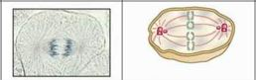
PHASE NAME: _____________________
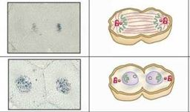
PHASE NAME: _____________________
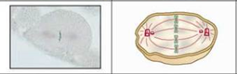

PHASE NAME: ____________________
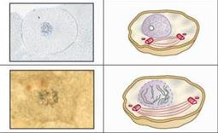
PHASE NAME: _____________________
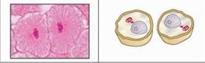

PART B - Below are pictorial representations of the phases of a plant cell cycle including interphase and cell division (mitosis and cytokinesis).
INSTRUCTIONS:
- Name the phases of mitosis - Prophase (early/late), Metaphase, Anaphase, Telophase (early/late) and cytokinesis below. (NOTE: THEY ARE NOT IN THE PROPER ORDER).
- Provide a summary for each of the phases in the spaces provided.
PLANT CELL CYCLE
STAGE NAME AND PICTORIAL REPRESENTATION | SUMMARY
INTERPHASE  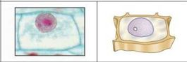 | -G1 phase: The cell increases in size (period of growth) and synthesizes new proteins and organelles.  -S phase - As the cell prepares for mitosis, the chromosomes replicates during this phase of interphase during the cell cycle.  -G2 phase - Organelles and molecules required for cell division are produced and ready to start mitosis (then cytokinesis).
PHASE NAME: _____________________
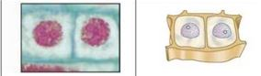
PHASE NAME: _____________________
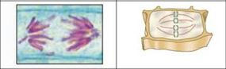
PHASE NAME: _____________________
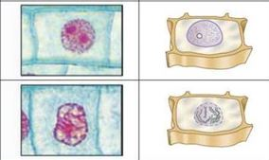
PHASE NAME: _____________________
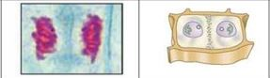
PHASE NAME: _____________________
