Science 9 – Section 5.5 Cell Division Assignment – Value 65 October 4, 2016
Name: ________________________________DUE DATE: October 11, 2016
- FILL IN THE BLANKS – Using notes/textbook find the missing word(s) for each of the following below. Value 37
- The cell cycle is a series of events or stages that cells go through as they ______________ and __________________.

- The proper order of the phases of the cell cycle are G₁ (growth phase), ___________________________, ___________________________, and the ____________________________.

- Cell division consist of two major stages which include the following: ________________________________ and _____________________________

- During the G₁ or growth phase the cell ____________________ in cell size and the __________________ of new proteins and organelles occurs.

- During this phase, _______________________, the chromosomes are replicated and DNA synthesis takes place.

- This first stage of cell division, mitosis, is described as the division of the _______________.

- The second stage of cell division, called ____________________, is described as the division of the _______________________.

- Interphase is the period of growth that occurs between cell divisions and includes the following events: _____________, _____________, and ____________.

- Genetic information is passed from one generation to the next on structures called ___________________________.

- Chromosomes are made of the following two components: _________________ and __________________.

- Each chromosome consists of _____________ identical sister _____________________.

- Biologists divide the events of mitosis into four phases. Identify the phases in the correct order. (1) __________________ (2) _____________________ (3) _________________ and (4) ___________________________

- __________________ is the name of the phase of mitosis in which chromosomes are visible (shorten and thicken).

- During this phase of mitosis, ____________________, the nuclear membrane begins to fade or dissolve.

- During this phase of mitosis, ___________________________, the double stranded chromosomes line up across the center or equatorial plate of the cell.

- During this phase of mitosis, __________________________, the chromosome (or sister chromatids) separate and move to the opposite ends or poles of the cell.

- Cytokinesis begins during this phase of mitosis. _________________________

- Cytokinesis is described as ______________ phase of cell division in which the ____________________________ and __________________________ separate into two equal parts to form two identical daughter cells.

- When the cell membrane during cytokinesis is drawn or pinched inward causing the cytoplasm to pinch in half. The resulting indentation is called a _____________________.

- Cytokinesis in plant cells forms a ______________________ along the middle, creating two new cells.

- A normal cell of a pigeon has 80 chromosomes. After the cell has undergone mitosis, one would expect to find _____________ chromosomes in each new cell produced.

- Missing or extra chromosomes after the process of mitosis may cause the following to occur:
- Cells to form a mutation.
- Cells to not function properly and die.
- All of the above.

- A. Identify each of the following graphics as one of the four phases of mitosis. Value 4
B. Label each structure (as indicated below). Value 6
C. Indicate (below each graphic) what is occurring in each of the following phases of mitosis. Value 10
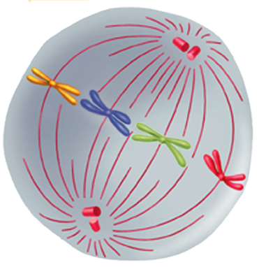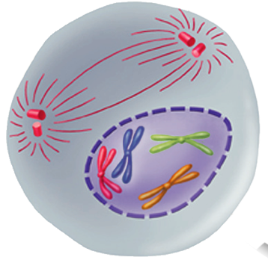

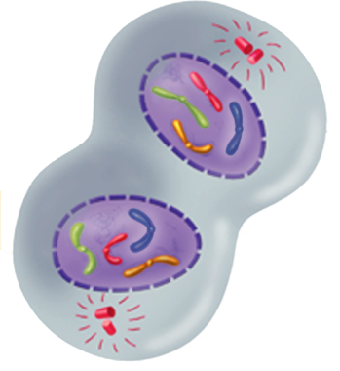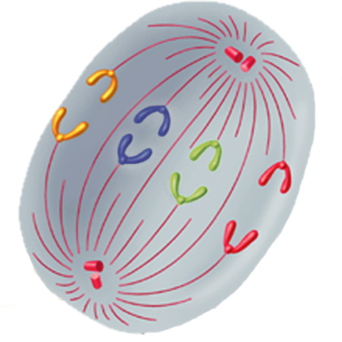

D. Explain how is plant cell cytokinesis difference from animal cell cytokinesis? Value 4

E. Draw an example of each type (plant cell cytokinesis & animal cell cytokinesis ONLY). Label the diagrams you provide below. Value 4

Once you have completed all the assignment, review your responses and then place a smiley face below!
Total Value 65

