Science 9 -Sexual and Asexual Reproduction Assignment Questions – Value 32 – OCT 13/16
IMPORTANT: STUDENTS REQUIRE THEIR TEXTBOOK & NOTES!!!
Name: ___________________________________ DUE: MONDAY, OCTOBER 17/16
- Name an advantage and a disadvantage of the forms of reproduction, asexual and sexual? Value 4
Asexual reproduction: Sexual reproduction:
Advantage: Advantage:
ANS: ______________________________ ANS: ________________________________
___________________________________ _____________________________________
___________________________________ _____________________________________
___________________________________ _____________________________________
Disadvantage: Disadvantage:
ANS: ______________________________ ANS: ________________________________
___________________________________ _____________________________________
___________________________________ _____________________________________
___________________________________ _____________________________________

- Page 190 - How (name of process) can a living plant reproduce without seeds? Provide an example. Value 2
ANS: _______________________________________________________________________
____________________________________________________________________________
Example: ____________________________________________________________________

- On page 191 (below Figure 2) is a summary of asexual reproduction techniques (letters a to e). List the techniques (name of) below: Value 5
a. _____________________________________
b. _____________________________________
c. _____________________________________
d. _____________________________________
e. _____________________________________

- Page 194 – Cloning is the process of forming ___________________ offspring from a single cell or tissue. Cloning is referred to as _________________________ reproduction. Value 2

- Name an advantage of cloning. Value 2
ANS: _______________________________________________________________________
____________________________________________________________________________

- Name a disadvantage of cloning. Value 2
ANS: _______________________________________________________________________
____________________________________________________________________________

- Page 208 –
- What is the name of the male sex cells of the flower? Value 1
ANS: _____________________________________

- Where are they (male sex cells of the flower) produced? Value 1
ANS: _____________________________________

- Where is the anther located on the flower? Value 1
ANS: ____________________________________________________________

- Page 208 –
- What is the name of the female sex cells of a flower? Value 1
ANS: _____________________________________

- Where is sex cells located (structure) in the flower? Value 1
ANS: _____________________________________________________________

- Page 208 - Define pollination. Value 1
ANS: _______________________________________________________________________
____________________________________________________________________________

- Page 210 – Label the diagram of the flower below using the LETTERS A TO I ONLY provided word list: Value 9
WORD LIST:
- petals C. anther E. stigma G. ovary I. pistil
- filament D. stamen F. sepal H. style
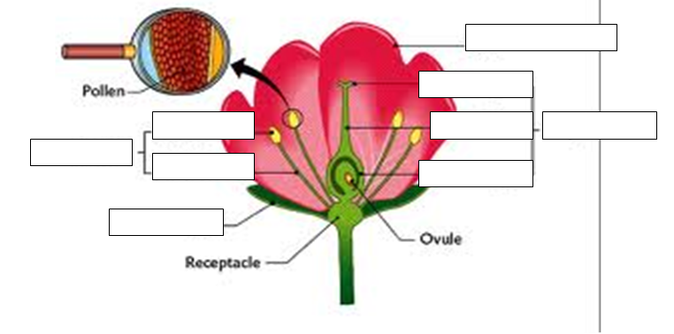BONUS QUESTION: WHAT ORGANISMS ARE NECESSARY IN OUR ENVIRONMENT IN ORDER FOR PLANTS TO POLLINATE & REPRODUCE? VALUE 1 ANS: ______________________________

