Cell Structure and Function Test Review Questions – Science 9
Name: ____________________________________________ Date: September 27, 2016
SHORT ANSWER – ANSWER ON YOUR OWN PAPER
- What are organelles?
- (a) What is the cell wall composed (made of)?
(b) What is the cell or plasma membrane composed (made of)?
(c) What are the functions of the cell or plasma membrane?
- What are the main functions of the nucleus of a cell?
- Name the organelle that break down glucose (sugar) to provide the cell with energy.
- Name the organelle involved in protein synthesis (making of proteins).
- Are lysosomes found in both plant and animal cells?
- Indicate (name) the organelle based on the descriptions indicated below:
a. The green pigment needed to carry out photosynthesis to make sugars (food).
b. Two small structures found near the nucleus are involved in cell reproduction.
c. Uses energy from food (glucose) to make high-energy compounds to provide the cell with energy.
d. Saclike structure that stores materials such as water, salts, proteins, and carbohydrates.
e. To assist with the management or the movement of substances within the cell (highway system).
- List two structures not common to animal cells (that plant cell possess or have):
- ________________________________
- ________________________________

- What evidence would indicate one is looking at an animal cell and not a plant cell?

- Name organelles common to both animal and plant cells:
____________________________ __________________________
____________________________ __________________________
____________________________ __________________________
____________________________ __________________________
____________________________ __________________________

- Label the following plant and animal cell diagrams using the word list provided below.

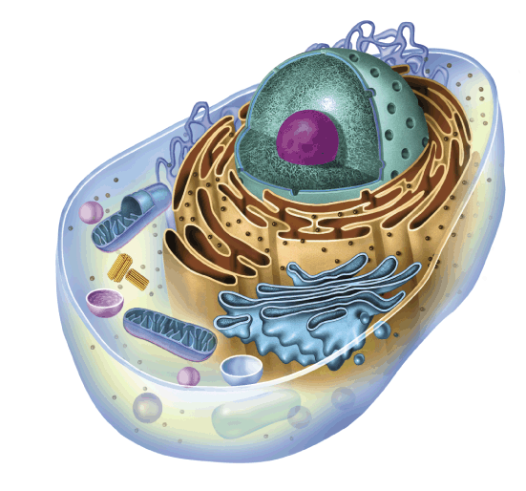

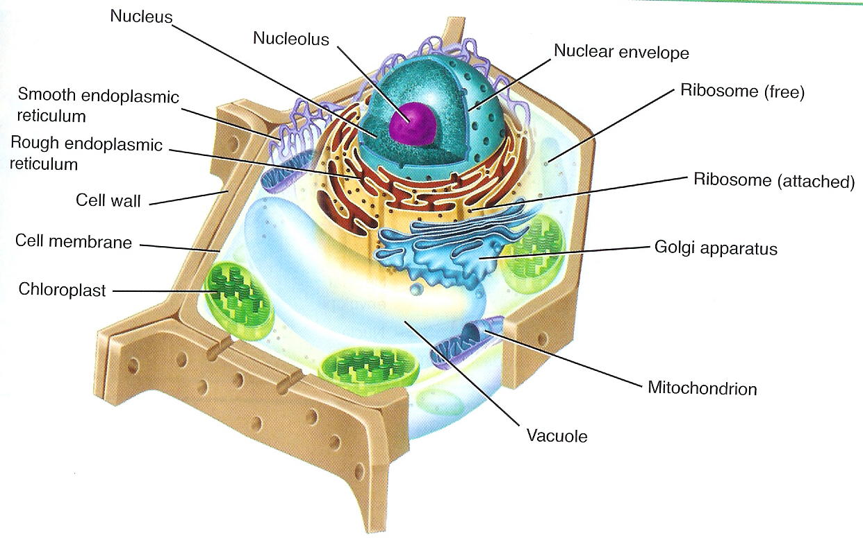

WORD LIST:
- nuclear envelope B. nucleolus C. rough endoplasmic reticulum D. cell/plasma membrane
E. chloroplast F. mitochondrion G. vacuole H. smooth endoplasmic reticulum
I. cell wall J. lysosome K. chromosomes L. ribosome (free) M. ribosome (attached)
N. centrioles O. Golgi apparatus

- Label the following microscope using the LETTERS PROVIDED (A TO N) next to each word in the list below. Provided below.
WORD LIST
A - medium power objective F - body tube K - base
B - coarse adjustment knob G - diaphragm L - stage clips
C - fine adjustment knob H - high-power objective M - stage
D - illuminator/light I - low-power objective N - arm
E - revolving nosepiece J - eyepiece or ocular
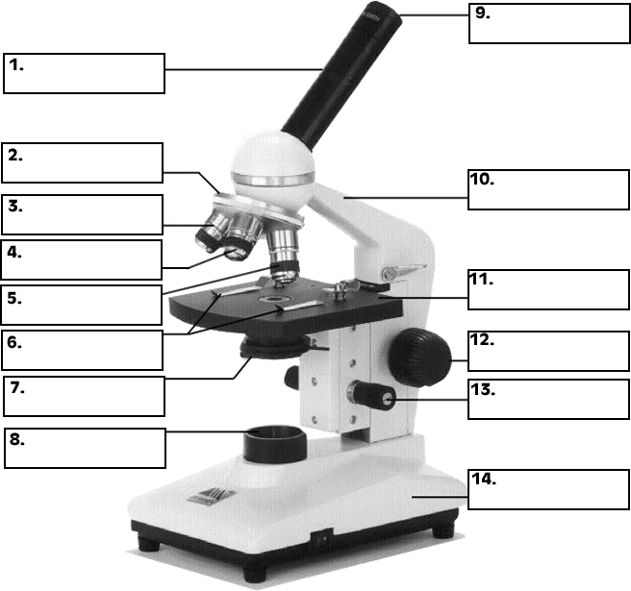
40x
10x
4x
- State the functions of the following parts of the microscope:
- Opening of the stage –
- Stage clips –
- Body tube –
- Fine adjustment knob –
- Revolving nose piece -
- Stage
- Indicate how to properly carry a microscope in the lab?
- Name any give safety tips everyone should follow when in the lab?

