1# WATERCOLOUR CENTER
Materials: Water Colour, Oil Pastels, brushes, chart paper, watercolour paper, pencil, eraser, pencil crayons.
Focus Elements | Focus Principals
Space  Shape  Colour | Emphasis

Vocabulary
- Analogous  - Colour Wheel  - Colour Scheme | - Primary colours  - Secondary colours

Learning Activity: In your sketchbook, create a nice big colour wheel. Add the colour as seen below. Can you identify the primary & secondary colours, and an analogous colour scheme.

An Analogous colour scheme is made of 3 colours right next to each other. Can you colour 2 examples of an analogous colour scheme in your sketchbook?
Final Activity/Steps | Example
- Create a simple outline drawing of an object. | 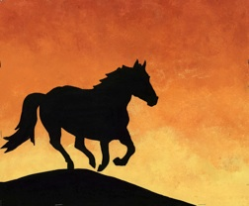
- Using a DARK coloured oil pastel, colour in the entire object.
- Using an analogous colour scheme, paint the background with watercolour.
- When dry, you can add more details in black, or darker colours (optional)

Reflection: In your sketchbook – write your own definition of Space, Shape, Colour and Emphasis. On the chart paper as a group, write one thing you learned about Space, Shape, Colour and Emphasis. Then as a group write a piece of advice for tomorrow’s group about the activity.
2# PEN AND INK
**Will stain - Very Permanent**
Materials: Calligraphy pens and tips, India Ink, paper, design idea sheets, cardstock paper, cursive alphabet.
Focus Elements | Focus Principals
Line  Value | Variety  Balance

Vocabulary
- Calligraphy  - India Ink | - Pattern

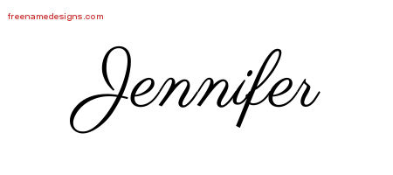
Learning Activity: Look at the design ideas sheet. In your sketchbook, practice at least 3 of the patterns from the sheet. Then look at the cursive writing sheet and practice writing your name using the pen and ink.

Final Activity/Steps | Example
- Use the bookmark paper and draw a continuous “crazy” line that touches all 4 sides of the bookmark. | 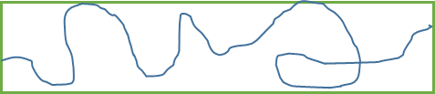
- Fill in each of the shapes created by your crazy line with patterns, textures or design ideas.
- Make sure to fill in some of the design elements to give your work contrast, try to make your work balanced by adding darker/lighter areas in more than one area.

Reflection: In your sketchbook – write your own definition of Line, Value, Variety and Contrast. On the chart paper as a group, write one thing you learned about Line, Value, Variety and Contrast. Then as a group write a piece of advice for tomorrow’s group about the activity.

3# CHALK PASTEL ON COLOURED PAPER
Materials: coloured paper, chalk pastels, magazines, pencil.
Focus Elements | Focus Principals
Value  Form | Unity  Contrast

Vocabulary
- Blending/Shading  - Sphere | - Background  - Subject

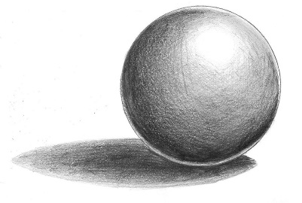
Learning Activity: In your sketchbook, draw a circle and a long skinny rectangle. Turn the circle into a Sphere by adding Shading. Turn the rectangle into a value scale that goes from lightest to darkest.

Can you explain, in your sketchbook, The difference between a SHAPE and FORM?
Show how to make a SHAPE into a FORM
Final Activity/Steps | Example
- Find an image in a magazine. | Examples of pastel work is on the smartboard (so you can see them in colour)!
- Choose a sheet of coloured paper that is a very different colour than your image to give your work CONTRAST.
- Draw the image from the magazine onto the coloured paper.
- Colour the image using the chalk pastels. Use similar colours to give your work UNITY.
- Add shading to your image to make your work 3D.

Refelction: In your sketchbook – write your own definition of Value, Form, Unity and Contrast. On the chart paper as a group, write one thing you learned about Value, Form, Unity and Contrast. Then as a group write a piece of advice for tomorrow’s group about the activity.

4# MINI STILL LIFE
Materials: Pencil, Charcoal, Paper, Still Life, Eraser, View finder.
Focus Elements | Focus Principals
Space  Form | Proportion  Unity

Vocabulary
- Still Life  - Blind contour | - Scale  - Contour

Learning Activity: Without looking at your drawing, draw a picture of your hand (no peeking!). Go really slow and look at all the details. When you are done, your drawing should look like the picture below. This is called a Blind Contour drawing. Now try again, but this time you can look at your hand sometimes (try to keep looking at the page more).

What was it like drawing without looking at the paper? How did it make you feel? Record your opinion in your sketchbook.
Final Activity/Steps | Example
- Chose a place to sit around the still life (the objects on the table). Make sure you have pencil or charcoal. | 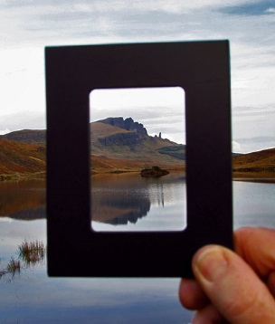
- Hold the view finder with your arm out straight. Close one eye and look through the view finder. This will help you select an area of the still life to draw.
- Now draw the objects that you selected in the viewfinder. HINT: it may be easier to start with the objects that touch the outside edge of the viewfinder. | 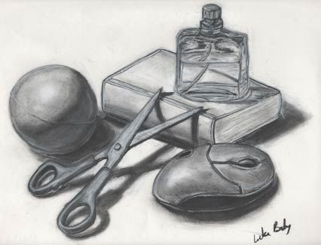
- Keep drawing, check your view finder often.
- Try to draw all the object in your view finder – remember to check their PROPORTION (their size and how the objects look next to each other).
Refelction: In your sketchbook – write your own definition of Value, Form, Unity and Contrast. On the chart paper as a group, write one thing you learned about Value, Form, Unity and Contrast. Then as a group write a piece of advice for tomorrow’s group about the activity.

5# MIXED MEDIA PICASSO PORTRAIT
Materials: coloured paper, chalk pastels, magazines, pencil, paint, ink, glue, scissors, dice.
Focus Elements | Focus Principals
Texture  Shape | Proportion  Movement

Vocabulary
- Mixed Media  - Portrait  - Distortion | - Collage  - Medium

Prep the Surface Activity:
Using your sheet of paper, draw, collage, write or paint the surface of the paper until it is all covered. Use several mediums to make the paper interesting.

Final Activity/Steps | Example
- Play “Roll a Picasso” using the sheet and dice provided. | Examples of Picasso Portraits are on the smartboard (so you can see them in colour)!
- Draw the facial elements onto the background you made to create a face. Make different parts of the face bigger or small to play with PROPORTION.
- When the face has been completed, fill it with colours and TEXTURE.
- Add dark lines to define the shapes of the face and any other elements you included. This will help your eyes MOVE through the artwork.

Refelction: In your sketchbook – write your own definition of Texture, Shape, Proportion and Movement. On the chart paper as a group, write one thing you learned about Texture, shape, proportion and movement. Then as a group write a piece of advice for tomorrow’s group about the activity.

