Famous Artists - Find many more online!
- Ansel Adams
- Richard Avedon
- Georg Baselitz
- Jean Michel Basquiat
- Paul Cezanne
- Salvador Dali
- Edgar Degas
- Ken Done
- Damien Hirst
- Winslow Homer
- Edward Hopper
- Jasper Johns
- Frida Kahlo
- Wassily Kandinsky
- Anselm Kiefer
- Gustav Klimt
- Emily Kngwarreye
- Leonardo da Vinci
- Roy Lichtenstein
- Norman Lindsay
- Elwyn Lynn
- Franz Marc
- Joan Miro
- Claude Monet
- Henry Moore
- Albert Namatjira
- Barnett Newman
- Georgia O'Keeffe
- John Olsen
- Francis Picabia
- Pablo Picasso
- Jackson Pollock
- Robert Rauschenberg
- Rembrandt
- Gerhard Richter
- Ginger Riley
- Diego Rivera
- Norman Rockwell
- Susan Rothenberg
- Mark Rothko
- Henri Rousseau
- Julian Schnabel
- Arthur Streeton
- Yves Tanguy
- Antoni Tapies
- Rover Thomas
- Cy Twombly
- Vincent van Gogh
- Andy Warhol
- Brett Whiteley
- Fred Williams
- Andrew Wyeth

Draw your sketch here!

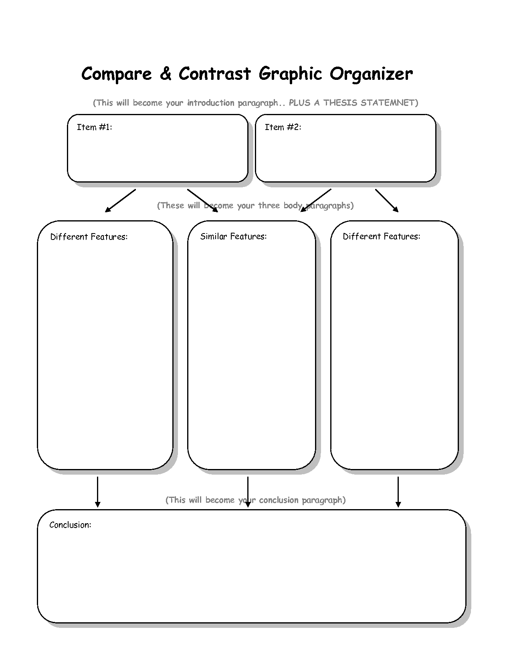
For your assignment, you may create a reproduction of one of their famous works (easiest) OR you will create a painting in the style of the artist you have selected (medium) OR you can use your imagination to combine the styles of the two artists you compared and create a new work or reproduction (hardest). Create a sketch in the box under the list on the other side of this sheet. *Tip – print a copy of the work you want to use AND take a photo with your phone or device to get a colour references.
Identify 2 famous artists
Explain (draw or write) how they are the same/different
Explain here which artist you prefer and why?
Artist 1
Artist 2

