BIO 12 Fetal Pig Student Dissection Manual
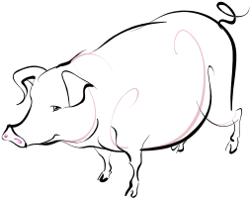

Background:
Like human, the pig is a placental mammal, meaning that the fetus received nourishment from the mother through the umbilical cord. Because the anatomy of the fetal pig resembles that of other placentals, this laboratory serves two important functions. It provides a representative overview of the vertebrate anatomy and provides the framework for understanding functioning body systems.
Read and follow the procedure carefully. Accompanying diagrams are designed to provide reference only. Use the appropriate dissecting instruments. This and the following lab have been designed to minimize the use of a scalpel.
Objectives:
- Identify important external structures of the fetal pig.
- Identify major structures associated with a fetal pig's digestive, respiratory, circulatory, urogenital, & nervous systems.
- Compare the functions of certain organs in a fetal mammal with those of an adult mammal.
Materials:
Preserved fetal pig, dissecting pan, dissecting tools (probe, dissecting pins, scalpel, scissors, forceps) apron, gloves, safety goggles, string, plastic bag, metric ruler, paper towel
Safety Notes:
Wear safety goggles, gloves, and an apron at all times. If skin or clothing comes in contact with any chemicals, wash off with water immediately. If you get chemicals in your eyes, rinse using the eye splash station set up in the lab (10 minutes approximately). Work in a well ventilated area. When you are finished the activities, clean your area, wash your hand thoroughly, and on the last day dispose of the specimens as instructed by your teacher.
Pre-lab:
Before observing internal or external structures of the fetal pig, research the information outlined by teacher during class (using classroom notebooks). You will be working in groups of 2 students and may have to refer to more than one resource to complete your research. During the lab, share information gathered with fellow group members and with other dissection groups.
Mandatory:
All students must wear a lab apron, eye cover (goggles or glasses), and gloves.
DO NOT LEAVE THE LAB IF YOU FELL FAINT OR DIZZY – TELL TEACHER!
No loose clothing, wear protective shoes, tie back long hair, no gum/food/drinks, no contacts lenses to be worn, wipe spills around working area/floor, and always proceed with caution!!! SAFETY FIRST!!!!!

Day 1 – Fetal Pig - External Anatomy
- Obtain a fetal pig and rinse off the excess preservative by holding it under running water. Lay the pig on its side in the dissecting pan and locate dorsal, ventral, and lateral surfaces. Also locate the anterior and posterior ends. Label on student hand-in sheets.
- A fetal pig has not been born yet, but its approximate age since conception can be estimated by measuring its length. Measure your pig's length from the tip of its snout to the base of its tail and record this on your student hand-in sheets provided by your teacher. Use the length/age chart you found in your research to determine your answer.
- Examine the pig's head. Locate the eyelids and the external ears or pinnae. Find the external nostrils.
- Study the pig's appendages and examine the pig's toes. Count and record the number of toes and the type of hoof the pig has. Record on student hand-in sheets.
- Locate the umbilical cord. With scissors, cut across the cord about 1 cm from the body. Examine the 3 openings in the umbilical cord. The largest is the umbilical vein, which carries blood from the placenta to the fetus. The two smaller openings are the umbilical arteries which carry blood from the fetus to the placenta.
- Lift the pig's tail to find the anus. Study the ventral surface of the pig and note the tiny bumps called mammary papillary. These are present in both sexes. In the female these structures connect to the mammary glands.
- Determine the sex of your pig by locating the urogenital opening through which liquid wastes and reproductive cells pass. In the male, the opening is on the ventral surface of the pig just posterior to the umbilical cord and the scrotum containing the testes can be located just below the anus. In the female, the opening is ventral to the anus. A small, spiked tissue called the genital papilla projects from the urogenital opening. Record the sex of your pig on student hand-in sheets.
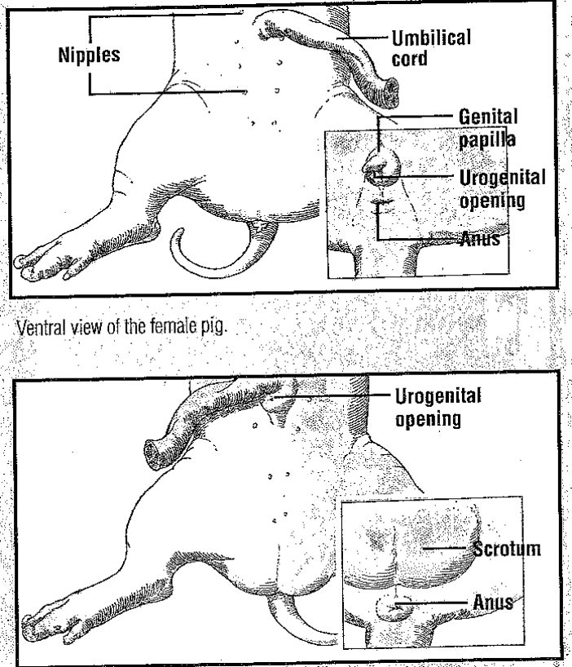

- Carefully lay the pig on one side in your dissecting pan and with scissors, make a 3-cm incision in each corner of the pig's mouth. Your incision should extend posteriorly through the jaw.
- Spread the jaws open and examine the tongue.
- Observe the palate on the roof of the mouth. The anterior part of the palate is the hard palate, while the posterior part is the soft palate.
- Locate the epiglottis, a cone-shaped structure at the back of the mouth. Above the epiglottis, find the round opening of the nasopharynx. This cavity carries air from the nostrils to the trachea, a large tube in the thoracic which supplies air to the lungs.
- Dorsal to the glottis, find the opening to the esophagus. Examine the tongue and note tiny projections called sensory papillae.
- Examine the teeth of the pig. Canine teeth are longer for tearing food, while incisor are shorter and used for biting. Pigs are omnivores.
- Label the drawing of the inside of the pig's mouth in student hand-in sheets.
- Clean up your materials and work area. Place fetal pig in plastic bag provided and seal end with masking tape. Teacher will instruct where to place them till next day. Put name on masking tape to identify your fetal pig (or on bag with a sharpie). Thoroughly wash your hands with soap.
Check work area to make sure everything has been picked up, area is clean, and prepared for the next lab day!
Day 2 – Fetal Pig – Part A: The Incision of the Abdominal Cavity
- Be sure to wear your lab apron, safety goggles, and gloves. Obtain your dissecting equipment and pig from area one was instructed to place them last day.
- Place the fetal pig on its dorsal surface in the dissecting tray.
- Tie a string securely around a front limb. Run the string under the tray, pull it tight, and tie it to the other front limb. Repeat this procedure with the hind limbs to hold the legs apart so you can examine internal structures.
- Study the diagram below to make your incisions with your scalpel (or scissors) while using forceps. The dashed lines numbered 1-5 show the first set of incisions that you will make.
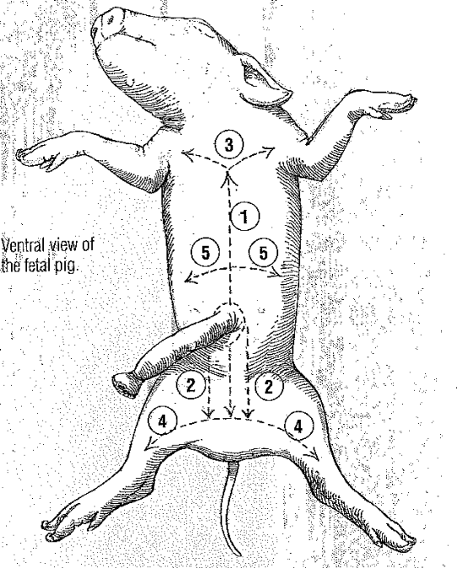
- With scissors, make the incisions in order, beginning with 1. Be sure to keep the tips of your scissors pointed upward because a deep cut will destroy the organs below. Also, remember to cut away from yourself.
- After you have made your incisions through the body wall, you will see the peritoneum, a thin layer of tissue that lines the body cavity. Cut through the peritoneum along the incision lines (one can use the probe or dissecting pins to tear the connective tissue). Use pins to hold back flaps of skin.
- Carefully continue cutting through the layer of muscle tissue and pin down flaps to expose the abdominal cavity (careful not to cut underlining organs).
Part B: Digestive System
- Locate the diaphragm, a sheet of muscle that separates the abdominal cavity from the thoracic cavity. Find the most obvious structure in the abdominal cavity, the brownish-colored liver. Count the number of lobes.
- Find the tube-like esophagus which joins the mouth and the stomach. Food moves down the esophagus by muscular contractions after being softened by saliva in the mouth. Follow the esophagus and locate the soft, sac-like stomach beneath the liver.
- With scissors, cut along the outer curve of the stomach. Open the stomach and note the texture of its inner walls. These ridges inside the stomach are called rugae and increase the area for the release of digestive enzymes. The stomach may not be empty because fetal pigs swallow amniotic fluid.
- The pig has a digestive system which is classified as monogastric or nonruminant. Humans also have this type of digestive system. They have one stomach. Locate the entrance to the stomach or esophageal area, the cardiac region which is largest, and the pyloric region where the stomach joins to the small intestine.
- At the end of the stomach, there is a sphincter, or ring-shaped muscle to control food leaving the stomach and entering the duodenum. Locate the cardiac sphincter at the junction of the stomach and esophagus, and the pyloric sphincter at the junction of the stomach and small intestine. Fetal pigs receive their nourishment from their mother through the umbilical cord.
- Identify the first part of the small intestine, the U-shaped duodenum, which connects to the lower end of the stomach. Pancreatic juice is made by the pancreas, and bile, made by the liver and stored in the gall bladder, are add to food here to continue digestion.
- Study the rest of the small intestine. Notice that it is a coiled, narrow tube, held together by tissue called mesentery. The soupy, partly digested food that enters the small intestine from the stomach is called chyme.
- Carefully cut through the mesentery and uncoil the small intestine. Note and record its length in centimeters. The mid-section is called the jejunum, while the last section is called the ileum.
- With scissors, remove a 3-cm piece of the lower small intestine. Cut it open and rinse it out.
- Observe the inner surface of the small intestine. Run your finger along it and note its texture. Using a magnifying glass or microscope, examine the villi, the tiny projections that line the small intestine and increase the surface area for absorption.
- Follow the small intestine until it reaches the wider, looped large intestine. Cut the mesentery and unwind the large intestine or colon. Measure and record its length.
- At the junction of the large and small intestine, locate a blind pouch called the caecum. The caecum has no known function in the pig.
- Notice that the large intestine leads into the rectum, a tube that runs posteriorly along the dorsal body wall. The rectum carries wastes to the opening called the anus where they are eliminated.
- Locate the thin, white pancreas beneath the stomach and duodenum. Pancreatic juice flows through pancreatic ducts to the duodenum.
- Between the lobes of the liver, find the small, greenish-brown gall bladder. Locate the hepatic duct which carries bile from the liver to the gall bladder.
- Find the spleen, a long, reddish-brown organ wrapped around the stomach. The spleen filters out old red blood cells and produces new ones for the fetus.
- Label the pig's body organs and completed questions in student lab hand-in sheets.
- Clean up your materials and work area. Place fetal pig in plastic bag provided and seal end with masking tape. Teacher will instruct where to place them till next day. Put name on masking tape to identify your fetal pig (or on bag with a sharpie). Thoroughly wash your hands with soap.
Check work area to make sure everything has been picked up, area is clean, and prepared for the next lab day!
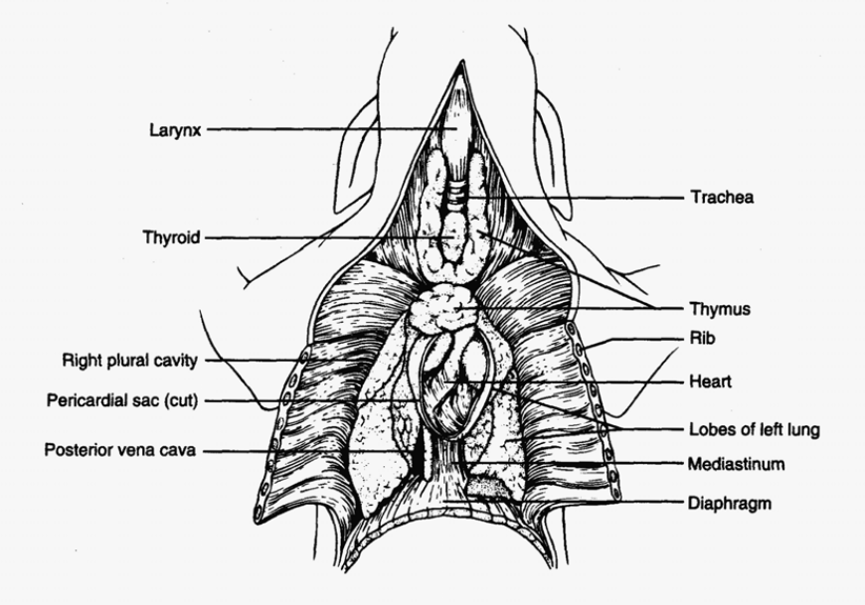
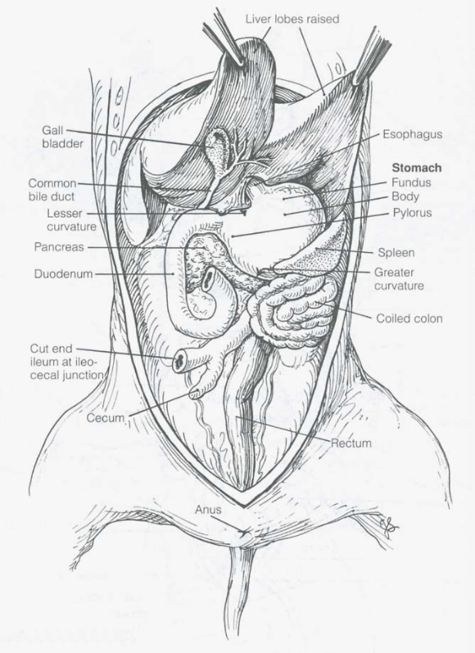

Day 3 – Fetal Pig - Respiratory System
- Be sure to wear your lab apron, gloves, and eye cover.
- Examine the diaphragm, a sheet of muscle that stretches across the abdominal cavity and separates it from the thoracic cavity where the lungs are located. The diaphragm isn't used by the fetal pig because gas exchange occurs through the umbilical cord. The diaphragm in adult pigs moves up and down changing air pressure in the chest cavity causing air to move into and out of the lungs.
- In order to see the upper part of the respiratory system, you will need to extend cut up under the pig's throat and make two more lateral incisions in order to fold back the flaps of skin covering the throat.
- In the thoracic cavity, carefully separate the pericardium or sac surrounding the heart and the diaphragm from the body wall.
- Locate the two, spongy lungs that surround the heart. The tissue that covers and protects the lungs is called pleura. The lungs haven't been used by the fetus so they have never contained air.
- Find the trachea, a large air tube that lies anterior to the lungs. The trachea is easy to identify because of the cartilaginous rings that help keep it form collapsing as the animal inhales and exhales.
- Notice that the trachea branches into each lung. These two tubes are called bronchial tubes. Inside the lungs these branch into smaller bronchioles that end with a grape-like cluster of air sacs or alveoli where oxygen and carbon dioxide are exchanged with capillaries.
- Lying ventral to the trachea or windpipe, locate the pinkish-brown, V-shaped structure called the thyroid gland. This gland secretes hormones that control metabolism.
- At the top, anterior end of the trachea, find the hard, light-colored larynx or voice box. This organ contains the vocal cords that enable the animal to produce sound.
- Locate the epiglottis at the top of the trachea. This flap of skin closes over the trachea whenever you swallow. Find the area called the pharynx at the back of the nasal cavity. Air enters an adult pig through the mouth or nose before passing through the pharynx and down the trachea to the lungs.
- Complete questions on student lab hand-in and label the diagram of the respiratory system.
- Clean up your materials and work area. Return your lab equipment and pig to the front bench and then thoroughly wash your hands with soap.

Day 4 – Fetal Pig - Circulatory System
- Be sure to wear your lab apron, gloves, and eye cover.
- Locate the heart. It is covered by a thin tissue called the pericardium. Remove this membrane to study the heart.
- Pigs, like all mammals, have four-chambered hearts. The right side of the heart pumps blood to the lungs, while the left side of the heart pumps blood to all other parts of the body. Locate the right and left sides of the heart.
- Each side of the heart has an upper and a lower chamber. Upper chambers are called atria and receive blood, while lower chambers are called ventricles and pump blood out of the heart. Locate the right and left atria and ventricle.
- Notice that the surface of the heart is covered with blood vessels. These are part of the coronary circulation, a set of arteries and veins whose only job is to nourish the heart tissue. Blockage in these vessels causes heart attacks.
- Anterior to the heart, locate another large vein that enters the right atrium. This vein, the anterior vena cava, brings blood to the right atrium from the anterior part of the body.
- Now lift the heart to view its dorsal surface. Observe the posterior vena cava that carries blood from the posterior part of the body and empties it into the right atrium.
- Find the pulmonary artery which leaves the right ventricle. After birth, this vessel carries blood to the lungs. However, in a fetus, a shunt called the ductus arteriosus allows fetal blood to bypass the lungs and go directly to the aorta, the largest artery of the body.
- Locate the pulmonary veins that enter the left atrium. After birth, these vessels carry oxygenated blood from the lungs to the heart.
- Identify the aorta, a large artery that transports blood from the left ventricle. Many arteries that carry blood throughout the body branch off of the
- Remove the heart by severing the blood vessels attached to it.
- Hold the dorsal and ventral surfaces of the heart with your thumb and forefinger and rest the ventricles on your dissecting tray. With a scalpel, cut the heart into dorsal and ventral halves. Caution: The scalpel is very sharp and always cut away from yourself.
- Remove any material inside the heart and expose the walls of the atria and the ventricles.
- Study the internal features of these chambers and note where vessels leave or enter each chamber. Locate the valves between each atrium and ventricle. These structures prevent blood from flowing backward in the heart.
- Complete the questions as outlined in student lab hand-in sheets and label the fetal pig heart diagram.
- Clean up your materials and work area. Return your lab equipment and pig to the front bench and then thoroughly wash your hands with soap.
Day 5 – Fetal Pig - Urogenital System
- Be sure to wear your lab apron, eye goggles, and gloves provided.
- Remove the digestive organs to study the excretory and reproductive organs that make up the urogenital system.
- Locate the large, bean-shaped kidneys lying against the dorsal body wall. Notice that they are covered by the peritoneum. Kidneys filter wastes from blood.
- Find the ureters, tubes which extend from the kidneys to the bag-like urinary bladder. The urinary bladder lies between the umbilical arteries and temporarily stores liquid wastes filtered from the blood.
- Lift the urinary bladder to find the urethra, the tube which carries urine out of the body. Follow the urethra to the urogenital opening on the outside of the pig's body.
- Make sure that incision #6 extends all the way to the anus but be careful to not cut too deep and damage the internal organs.
- Follow the directions below for locating the excretory and reproductive organs in either a male or female pig. When you finish observing the organs in a pig of one sex, exchange specimens with another classmate to view the organs in a pig of the opposite sex.
Male System
- In the male pig, locate the two scrotal sacs at the posterior end of the pig. If the pig is in the later stages of development, you will find a testis in each sac. If the pig is in an early stage of development, the oval-shaped testes will be in the abdominal cavity. These testes have not yet descended into the scrotal sacs.
- On each testis, find the coiled epididymis. Sperm cells produced in the testis pass through the epididymis and into a tube called the vas deferens. This tube crosses over a ureter and enters the urethra.
- Follow the urethra to the penis, a muscular tube lying just below the skin posterior to the umbilical cord. In mammals, the penis is the organ that transfers sperm.
- Label the diagram of the male urogenital system in the student lab hand-in sheets.
Female System
- In the female pig, find the two bean-shaped ovaries at the posterior end of the abdominal cavity. Observe the coiled fallopian tube attached to each ovary.
- Follow the Fallopian tube to the uterus. The uterus is dorsal to the urinary bladder and the urethra.
- Trace the uterus to a muscular tube called the vagina. The vagina will appear as a continuation of the uterus. Sperm from the male are deposited into this organ during mating. The vagina and the urethra open into a common area called the urogenital sinus. This cavity opens to the outside at the urogenital opening.
- Label the diagram of the female urogenital system in the student lab hand-in sheets. .
- Clean up your materials and work area. Return your lab equipment and pig to the front bench and then thoroughly wash your hands with soap.
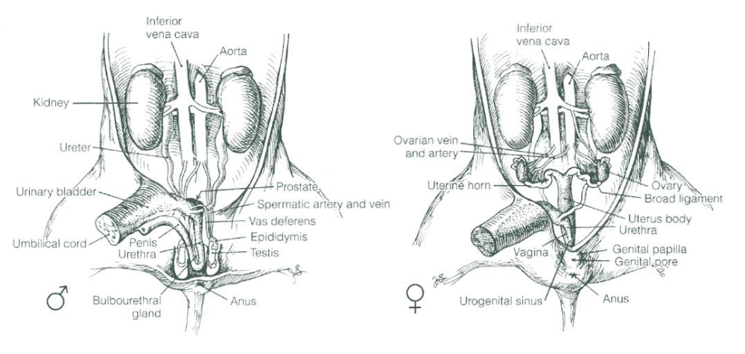

Day 6 – Fetal Pig - Nervous System
- Be sure to wear your lab apron and eye cover.
- With the pig dorsal side down, open both thoracic and abdominal flaps and locate the spinal column.
- Select a site along the spine and remove any organs blocking your view of the spine. Using a scalpel, expose the spine and locate any emerging nerves. Trace one as far as you can into the body.
- Place the pig dorsal side up in your dissecting tray. In the thoracic region, remove the skin and muscle to expose 10mm of the vertebral column.
- Using forceps to grip the spine and scissors to cut, open the vertebral canal by cutting off the vertebral arch. Note the dura mater or outermost covering of the brain & spinal cord.
- Make a second cut on the other side of these vertebrae, and fold the spine section upward so you can view the cross-section. Locate the white and gray matter, dorsal and ventral root, central canal, and a dorsal root ganglion.
- With the dorsal side of the pig up, remove the skin from the entire skull.
- Cut through the skull near the center being careful not to break the meninges or membranes covering and protecting the brain.
- After the skull is open, chip away the pieces but do not use the scalpel blade for chipping.
- When the brain is completely exposed, locate the 2 large hemispheres called the cerebrum. Fissures indenting the surface of the cerebrum are called sulci (sulcus, singular). Gyri (gyrus, singular) are ridges projecting outward from the surface.
- Locate the longitudinal fissure or indention that runs laterally between the right and left cerebral hemispheres. The olfactory lobes that control smell are at the front of the cerebrum. The cerebrum controls thinking, senses, etc.
- Posterior to the cerebrum is the cerebellum. Locate the cerebellum and the transverse fissure that separates it from the cerebrum. The cerebellum consists of 2 lateral hemispheres and is involved with the control of muscles and coordination.
- Find the fissure between the right and left cerebellum hemispheres called the vermis.
- Carefully remove the brain from the skull in order to locate the hind section of the brain known as the medulla oblongata. The medulla connects the brain to the spinal cord and controls all vital functions of the body such as heart beat and breathing.
- Label the diagrams of the brain and spinal cord.
- Clean up your materials and work area (wash tables). Return all lab equipment (rinse thoroughly dissecting tray and tools used). Place the pig/parts in the bag provided and bring to the front table in the lab. Then thoroughly wash your hands with soap.

CONGRATULATIONS YOU HAVE SUCCESSFULLY COMPLETED & SURVIVED THE FETAL PIG DISSECTION LAB
REMINDER: SUBMIT DAY 1 TO DAY 6 LAB REPORT HAND-IN

