Section 39-3 End of Chapter Assigned Questions
Page 1015 #1 and 5
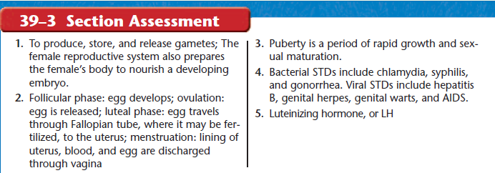
Page 1027 #6 – 10, #17 – 24 Page 1028 #33-35, 37, 38 Page 1029 #1,2, #4-7
