Financial & Workplace Mathematics – Bar/Histogram/Line/Circle Graphs Assignment
Name: ____________________________ Value 50 - Date: Feb 14, 2017 –DUE: FEB 15/17
- Fill in the blanks – Value 8

- Bar graphs are used for __________________ data that have categories.

- Histograms are a type of _____________ graph which shows the number of times data appear within a certain __________________ (such as the numbers of players between 12 and 16 in height).

- ______________________ are bar graphs that uses vertical bars without any gaps between them.

- Both of the following graphs can be difficult to read accurately because some bars do not end on a grid line. ____________________ and _________________ graphs

- Pie or circle graphs represent _____________________ data that can be used to compare amounts. It shows each amount as a ___________________ of the total.

- Short Answer – Value 12
Number of  Hours Watched | Tally | Frequency
0–5.5 | ll | 2
5.5–10.5 | lll | 3
10.5–15.5 | llll | 5
15.5–20.5 | llll lll | 8
More than 20.5 | llll llll ll | 12
- Tara’s class was surveyed about how many hours of television they watch. The results are shown.

- Which type of graph would represent the data accurately? Why? Value 2
ANS: __________________________________________________________________
- Which interval has the largest frequency? Value 1
ANS: _________________________________________________
- Which interval has the smallest frequency? Value 1
ANS: _________________________________________________

- Ann surveyed 40 students on their favorite type of online game.
Game Type | Number of Votes
Puzzle | 4
Strategy | 3
Racing | 15
Action | 12
Sports | 6

- What type of graph would best show that a majority of the students like racing and action online games? And why? Value 2
ANS: _________________________________________________________________
- Describe one advantage of the graph you choose for part a. Value 2
ANS: _________________________________________________________________

- Kathleen sells jewelry to her family and friends. She tracks her monthly sales and displays them on a graph.
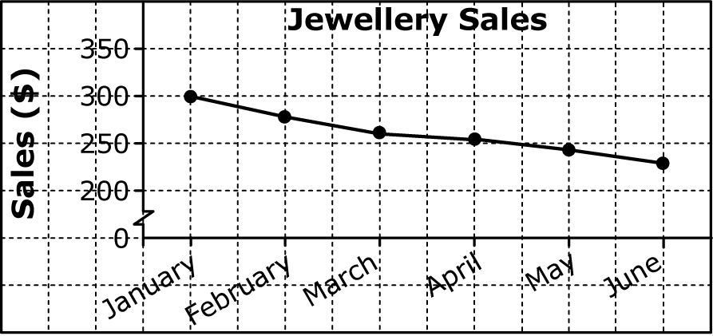
- Kathleen say that her sales have declined (dropped) dramatically since January. Do you agree with her statement? Why or why not? Value 2
ANS: _________________________________________________________________
- In which month did Kathleen have the least amount of sales? Value 1
ANS: _________________________________________________________________
- In which month did Kathleen sell for $250 worth of jewelry? Value 1
ANS: _________________________________________________________________

- Graphing – Value
- Go to page 164 in your textbook and complete question #4 (a, b, and c) below. Value 15
- Histogram – Value 13

(b) ANS: ________________________________________________________ Value 1

(c) ANS: _________________________________________________________ Value 1

- From the data provided complete a circle/pie graph below. Value 15
MONTH | SALES ($) | Percent (Indicate values to attain percentage)
January | 450 | / = x 100% =
February | 525 | / = x 100% =
March | 398 | / = x 100% =
April | 276 | / = x 100% =
May | 510 | / = x 100% =
June | 600 | / = x 100% =
 | TOTAL: _______ | TOTAL:_______

Total Value 50

