Science 9 – Daily Science Review Questions for Exam – ANSWER BELOW OR ON OWN PAPER
NAME: ____________________________________________ JANUARY 2017
REPRODUCTION
Part 1
- What is the name of the four parts of the cell cycle?
- Name the two parts of cell division?
- Name (in the proper order) are the four phases of mitosis?
Part 2
- Name the structure of the cell responsible for regulating what enters or exits the cell.
- What is the function of the cell wall?
- What organelles make an animal cell different from a plant cell?
- What structure is responsible of the making of proteins?
Part 3
- This type of reproduction involves the union of sex cells to produce an organism.
- Name the three parts of the cell theory.
- What is a zygote?
- What are changes in the genetic code called?
Part 4
- During which phase of mitosis are chromosomes visible?
- During which phase of mitosis are chromosomes aligned at the center of the cell?
- How is cytokinesis different in animal and plant cells? Diagram
Part 5
- What is another name for cell membrane?
- What is the cell membrane composed of?
- What is the nucleus composed of?
- What is the function of the nucleus?
Part 6
- What are chromosomes composed of?
- DNA replication takes place during this phase of the cell cycle.
- Answer the following questions based on the events of a cell during telophase.
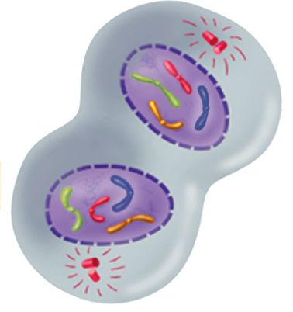
- What structures reaches the opposite end of the poles?
- Where are the newly formed chromatids located?
- What structure is reappearing?
- What type of cell is represented in the diagram?
- Cytokinesis begins and the ___________ and __________________ separate.
- What is the final product of cytokinesis?

Part 7
- What is the cytoplasm of the cell?
- TRUE OR FALSE: Most of the life processes takes place within the cytoplasm of the cell.
- Indicate the function of the following organelles:

- Mitochondria
- Endoplasmic reticulum
- Vacuole
- Ribosomes
- Centrioles

Part 8
- Name any three types of asexual reproduction (page 160) of textbook.
- Name two specialized cells that contain genetic information to produce a new organism.
- Is it possible for organisms to reproduce asexually and sexually? Give an example
- Name any two characteristics about cancer cells.
- A substance or energy that causes mutation is called a _______________________.
- Name three carcinogens.
Part 9
- What occurs during the G1 or First Growth Phase of the cell cycle?
- At the end of which phase of the cell cycle is the cell ready to start cell division?
- Interphase includes what three phases of the cell cycle?
- The series of events that cells go through as they grow and divide is called the _____________________.
- All of the following statements are false. What word(s) need to be changed to make the statements true?
- DNA replication takes place during the M phase (cell division) of the cell cycle.
- Cytokinesis usually occurs during anaphase of mitosis.
- During mitosis, sister chromatids separate from one another during metaphase.
- The two major stages of cell division include G₂ and prophase.
Part 10
- Name structures only found in animal cells and plant cells.
- These structures contain the green pigment chlorophyll.
- Plant cell walls are composed of a tough fiber called ___________________.
- Name the structures (A to E) labeled below.
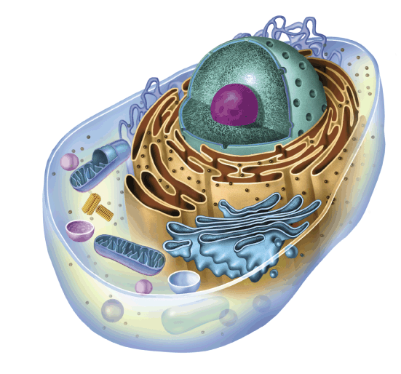
C
D
E
B
A
- What are organelles?
CHEMISTRY
Part 1
- Name the three parts of an atom.
- Name four types of power generating plants in New Brunswick.
- What is the name of the basic particle that carriers one unit of a negative charge?
- TRUE OR FALSE: Heat; light, sound, and electricity are all examples of the force that makes things move or change.
Part 2
- Name any two physical properties of water.
- What is invisible, state is a gas, and has no particular shape or volume?
- Name two categories of substances and give an example of each.
- When two pure substances are mixed together and they mix smoothly, the mixture is called a _____________________ an example of a _____________________ mixture.
- If particles do not mix well together then the mixture is described as a _____________________________mixture.
Part 3 (**Use Periodic Table)
- What element am I (name and/or symbol)?
- My neutron number is 51. ____________________
- My atomic mass is 192. ____________________
- My symbol is Ba. _________________
- My electron number is 19. ________________
- My proton number is 87. _________________
- Complete the following table by filling in the blanks. Use the periodic table to assist you.
Element | Symbol | Atomic Number | Atomic Mass | Number of Protons | Number of Electrons | Number of Neutrons
 |  | 13
Silver
 |  |  |  | 50
 |  |  |  |  |  | 120
 | Zn

- Construct a Bohr Diagram for the following elements:
- F or Fluorine
- K or Potassium

Part 4
- Indicate how energy (temperature) affects the phases of matter of water
- _______________ properties are the characteristics of a substance that you can observe with your senses. Give an example. ____________________________________
- What is the physical property of iron (with respects to shape and volume)?
- How does a gas differ from a liquid?
- How is a gas the same as a liquid?
- How does a gas differ from a solid?
- How is a gas the same as a solid?
- Name a chemical property of rubbing alcohol.
Part 5
- Identify the following symbols using the word list below:
WORD LIST:
Biohazardous Corrosive Flammable Compressed Gas
Oxidizing Poisonous Toxic Dangerously Reactive
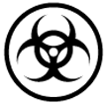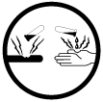
- What are (five examples each) of the “do’s” and “don’ts” with respects to lab safety?
- What is wafting?
- What does WHMIS stands for?
Part 6
- Which of the following is an example of a pure substance and which are examples of a mixture?

- Pizza - ______________________
- Oreo cookie - ___________________
- Distilled water ___________________
- Brass - ____________________
- Solid brass - _____________________

- Identify the following as a homogenous mixture or a heterogenous mixture.

- Tea - ________________
- Salt and pepper - ________________
- Donair - _______________
- Milk - ____________________
- Nails and screws - _______________
- Identify following as either a physical change or a chemical change.

- Foaming or fizzing - _____________
- Color of a substance - ____________
- Odor of a substance - _____________
- Color and odor of a substance
- Burning of a substance - __________
- Soured milk - ______________
- Shape of an object - _____________
- Tearing apart a piece of wood - _____
- Calculate the density of the following: (D = m/v)
- Timothy found a solid metal block that has a mass of 125 grams and
a volume of 25 cm³. What would be the density of the block?
- Find the density of a substance with a mass of 27 g and a volume of 7 cm³.
- A block of maple has a mass of 120 grams and a volume of 10 cm³. What is the density of the block?
- Find the density of a substance with a volume of 5 cm³and a mass of 35 g.

ELECTRICITY
Part 1
- What is a conductor? Give an example.
- What is an insulator? Give an example.
- What happens when two unlike charges are brought near each other?
- What happens when two like charges are brought near each other?
- An electrical circuit is the path along which ________________ travels.
Part 2
- Friction causes many of the effects produced by ______________ electricity.
- Friction is caused by two objects __________________ together and each object will develop their own _______________________________.
- Name a material that has a great electrostatic build up when compared to other types of materials.
- How can an electric charge be transferred?
- Name an electric charge that can be dangerous.
- The electric charge occurs when extra ______________________ from the ________________________ charged object get transferred by contact with an _________________________ object.
Part 3
WORD LIST: wire, magnet, dam, current, electrical, charge, metal rod, pressure, generator, mechanical, turbines
- A hydro plant uses the _______________ of the water coming from a ________ to make the _______________ move.
- A _____________ is the amount of electricity in a substance.
- _________________ is electricity that moves through a circuit.
- A ___________________ is a device that turns one form of energy (usually in the form of a fuel or ____________ energy) into another form of energy (usually into __________________ energy).
- An electromagnet is a ______________ that is wrapped with ___________ that becomes a powerful ______________ when electricity passes through the wire.
Part 4
- A nuclear plant, such as the one located in Pointe Lepreau near St. John, uses ________________, a metal that releases a large amount of heat in a nuclear reaction.
- TRUE OR FALSE: A scientist named Hans Oersted discovered that electricity could cause magnetism.
- Match the following symbols with the correct terms provided below:
WORD LIST:
closed switch one dry cell light bulb two dry cells
motor open switch appliance (resistance) wire
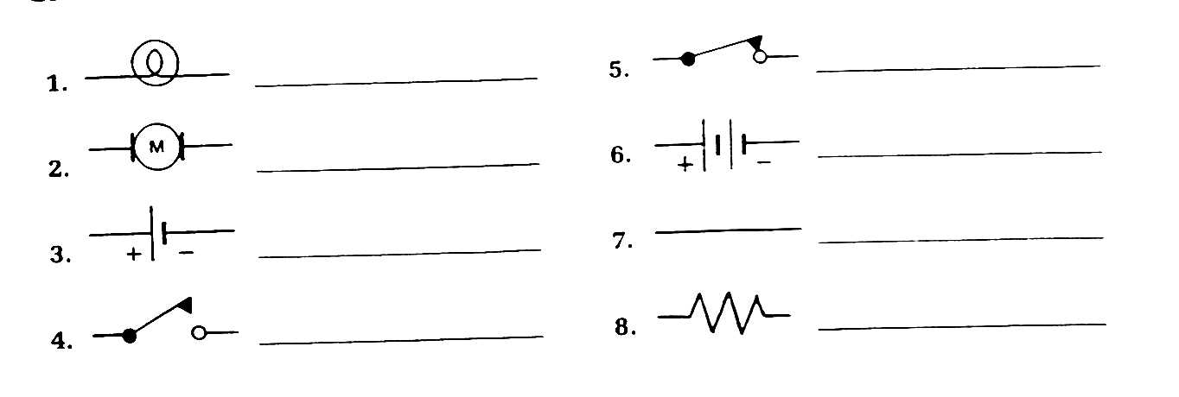

- Does electricity flow from plus to minus OR minus to plus?
- Name the three particles an atom is composed of.
- Why don’t we get most of our electricity from batteries?

