Science 9 – Daily Science Review Questions/ANSWERS for Exam – REPRODUCTION
NAME: ____________________________________________ JANUARY 2017
REPRODUCTION
Part 1
- What is the name of the four parts of the cell cycle?
- ANS: G1, S, G2, and M or cell division
- Name the two parts of cell division? ANS: mitosis and cytokinesis
- Name (in the proper order) are the four phases of mitosis? ANS: prophase, metaphase, telophase, and anaphase
Part 2
- Name the structure of the cell responsible for regulating what enters or exits the cell.
ANS: cell or plasma membrane
- What is the function of the cell wall?
ANS: The function of the cell wall is to provide support and protection.
- What organelles make an animal cell different from a plant cell?
ANS: Centrioles found in animal cells only and plant cells have chloroplast, cell wall and one large vacuole.
- What structure is responsible of the making of proteins?
ANS: The structure responsible for making of proteins is the ribosomes.
Part 3
- This type of reproduction involves the union of sex cells to produce an organism.
ANS: Sexual reproduction
- Name the three parts of the cell theory.
ANS:(1) All living things are composed of cells.
(2) Cells are the basic units of structure and function in living things.
(3) New cells are produced from existing cells.
- What is a zygote?
ANS: A zygote represents the union of an egg cell and a sperm cell (fertilized egg).
- What are changes in the genetic code called?
ANS: The changes in the genetic code are called mutations.
Part 4
- During which phase of mitosis are chromosomes visible?
ANS: Chromosomes are visible during prophase of mitosis.
- During which phase of mitosis are chromosomes aligned at the center of the cell?
ANS: Chromosomes align at the center of the cell during metaphase of mitosis.
- How is cytokinesis different in animal and plant cells? Diagram
Animal cell – furrow develops which is the in-pinching of the cell or plasma membrane
Plant cell – the formation of a cell plate on the inside of the cell to the outside forming a cell wall.

Part 5
- What is another name for cell membrane?
ANS: cell or plasma membrane
- What is the cell membrane composed of?
ANS: bilipid layer (or phospholipid layer)
- What is the nucleus composed of?
ANS: chromatin (or chromosomes), nucleolus, nuclear envelope, and nuclear pores
- What is the function of the nucleus?
ANS: The function of the nucleus is to be the control center of the cell of the cell’s activities and processes.
Part 6
- What are chromosomes composed of?
ANS: Chromosomes are made up of DNA and proteins.
- DNA replication takes place during this phase of the cell cycle.
ANS: S phase of the cell cycle
- Answer the following questions based on the events of a cell during telophase.
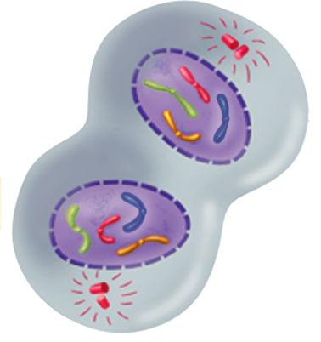
- What structures reaches the opposite end of the poles? ANS: centrioles
- Where are the newly formed chromatids located? ANS: Inside the reappearing nuclei.
- What structure is reappearing? ANS: nuclei
What type of cell is represented in the diagram? ANS: Animal cell due to the presence of centrioles.
- Cytokinesis begins and the cytoplasm and organelles separate.
What is the final product of cytokinesis? ANS: Two identical daughter cells is the final product of cytokinesis.

Part 7
- What is the cytoplasm of the cell?
ANS: Cytoplasm is all the living substance in a cell except the nucleus. Most cells are made up of cytoplasm.
- TRUE OR FALSE: Most of the life processes takes place within the cytoplasm of the cell.
ANS: TRUE
- Indicate the function of the following organelles:
- Mitochondria (ANS: The mitochondria (or powerhouse) break down glucose (or sugar) to provide the cell with energy.
- Endoplasmic reticulum (ANS: To assist with the management or the movement of substances within the cell)
- Vacuole (ANS: A large liquid filled sac that stores materials such as water, salts, protein, & carbohydrates)
- Ribosomes (ANS: Aids in the making of proteins on the rough ER)
- Centrioles (ANS: Are two small structures involved in cell reproduction)

Part 8
- Name any three types of asexual reproduction (page 160) of textbook.
ANS: Binary fission, budding, fragmentation, spore formation, and vegetative reproduction
- Name two specialized cells that contain genetic information to produce a new organism.
ANS: sperm and egg cell
- Is it possible for organisms to reproduce asexually and sexually? Give an example
ANS: Yes, bacteria cells reproduce mostly asexually but are capable of also reproducing sexually. Most plants reproduce sexually (process that results in seeds) but many reproduce asexually.
- Name any two characteristics about cancer cells.
ANS: Cancer cells divide uncontrollably, divide more quickly than normal cells, and are caused by mutations in the genes that regulate cell division.
- A substance or energy that causes mutation is called a carcinogen.
- Name three carcinogens.
ANS: viruses, radiation, and hazardous chemicals

Part 9
- What occurs during the G1 or First Growth Phase of the cell cycle?
ANS: The cell increases in size (period of growth) and synthesizes new proteins and organelles.
- At the end of which phase of the cell cycle is the cell ready to start cell division?
ANS: Once G₂ is complete, the cell is ready to start cell division.
- Interphase includes what three phases of the cell cycle?
ANS: Interphase includes G₁, S, and G₂ phases.
- The series of events that cells go through as they grow and divide is called the cell cycle.
- All of the following statements are false. What word(s) need to be changed to make the statements true?
- DNA replication takes place during the M phase (cell division) of the cell cycle. ANS: S phase
- Cytokinesis usually occurs during anaphase of mitosis. ANS: telophase
- During mitosis, sister chromatids separate from one another during metaphase. ANS: anaphase
- The two major stages of cell division include G₂ and prophase. ANS: mitosis and cytokinesis
Part 10
- Name structures only found in animal cells and plant cells.
ANS: animal cells have centrioles and smaller vacuoles than plant cells, plant cells have cell wall, chloroplast, and a large central vacuole
- These structures contain the green pigment chlorophyll. ANS: chloroplast
- Plant cell walls are composed of a tough fiber called cellulose.
- Name the structures (A to E) labeled below:
A: nucleolus
B: mitochondrion
C: centrioles
D: golgi apparatus
E: cell or plasma membrane
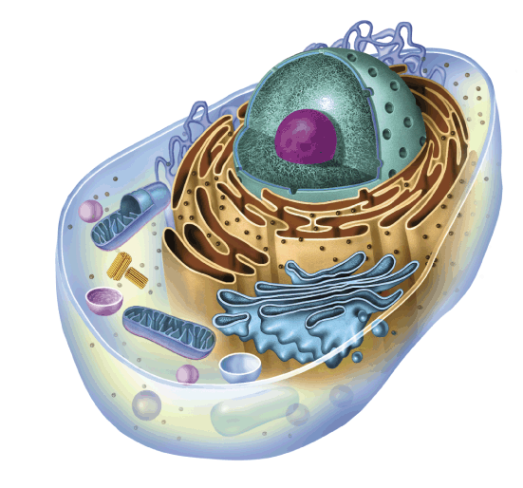
C
D
E
B
A
- What are organelles? ANS: Organelle is a term used to describe the parts or “machines of the cell factory”. They are small structures in the cytoplasm that have specialized jobs.

