Meiosis Chapter Test Review – Unit 11-4 Date: October 10, 2017
Name: _____________________ Period: _____ TEST: Friday, Oct 13/17
Multiple Choices
Write the letter that best answers the question or completes the statement on the line provided.

_____ 1. If an organism’s diploid number is 12, its haploid number is
a. 12. c. 24.
b. 6. d. 3.

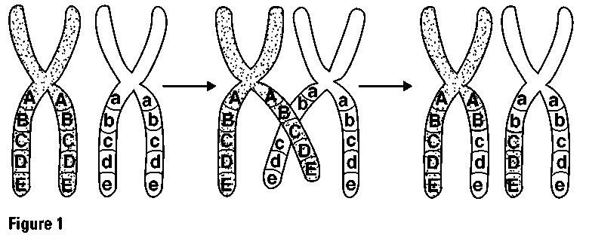
______ 2. What is shown in Figure 1?

a. independent assortment
b. anaphase I of meiosis

c. crossing-over
d. incomplete dominanc
_____3. Chromosomes form tetrads during

a. prophase of meiosis I.
b. metaphase of meiosis I.
c. prophase of meiosis II.
d. metaphase of meiosis II.
_____ 4. Unlike mitosis, meiosis results in the formation of
a. two genetically identical diploid cells.
b. four genetically different haploid cells.
c. four genetically identical haploid cells.
d. two genetically different diploid cells.

_____ 5. The number of chromosomes in a gamete is represented by the symbol
a. 2N. c. N.
b. X. d. Y

_____ 6. Gametes are produced by the process of
a. mitosis. c. crossing-over.
b. meiosis. d. spermatogenesis

____ 7. Unlike mitosis, meiosis results in the formation of
a. diploid cells. c. 2N daughter cells
b. haploid cells. d. X daughter cell
Completion
Complete each statement on the line provided.
- Meiosis produces four genetically different __________________________ cells.

- An organism’s gametes havethe number of chromosomes found in the organism’s body cells.

- If an adult organism’s body cells have the chromosome number of 22, the organism’s cell number would be ______________________.

- Meiosis is a process of a _______________________ division in which the number of chromosomes per cell is _________________ in half through the ________________________________ of homologous chromosomes in a diploid cell.
Short Answer
In complete sentences, write the answers to the questions on the lines provided.
- Define homologous chromosomes.
- How many sets of chromosomes are in a diploid cell (one or two)?
- What happens to the number of chromosomes per cell during meiosis? Contrast the cells produced by mitosis with those produced by meiosis.
- Compare and contrast Mitosis to Meiosis (similarities and differences).
- The stages of meiosis are classified into two divisions: meiosis I and meiosis II. Compare (prophase 1 to prophase II, etc.) and contrast these two divisions.

- Indicate an advantage and a disadvantage of the following processes:
- Mitosis
- Meiosis

- State the differences between meiotic divisions of a sperm cell to an egg cell.

