Pedigree Chart Exercise – Section 14-1

Name Class:____________ Date: October 19, 2017
Using Science Skills
Use the diagram below to answer the following questions on the lines provided.
The pedigree shows the inheritance of free earlobes and attached earlobes in five generations of a family. NOTE: Attached earlobes is caused by a recessive allele (f).
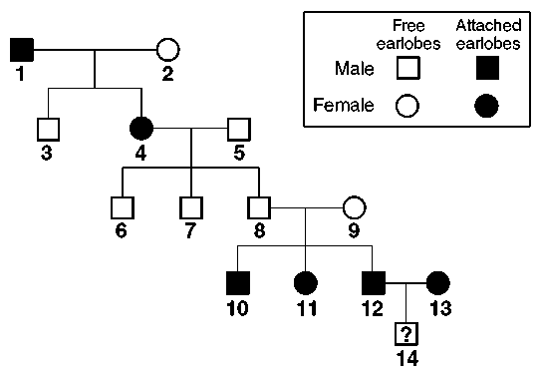
Figure 1
26. Inferring Is individual 2 in Figure 1 homozygous or heterozygous for free earlobes? Explain.

27. Interpreting Graphics In Figure 1, how many children of individuals 4 and 5 have attached earlobes?

© Pearson Education, Inc., publishing as Pearson Prentice Hall.
176
28. Inferring Can you be certain of the genotype of individual 5 in Figure 1? Explain.

Name Class Date
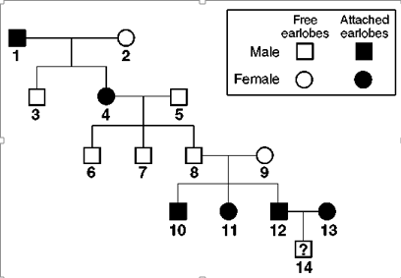

29. Predicting Predict the genotype and phenotype of individual 14 in Figure 1.

30. Inferring - In Figure 1, are any of the descendents of individuals 1 and 2 homozygous for free earlobes? Explain your answer.

