Science 9 – Daily Science Review Questions for Exam – ANSWER ON YOUR OWN PAPER
NAME: ____________________________________________ ARPIL 25, 2018
REPRODUCTION
Part 1
- What is the name of the four parts of the cell cycle?
- Name the two parts of cell division?
- Name (in the proper order) are the four phases of mitosis?
Part 2
- Name the structure of the cell responsible for regulating what enters or exits the cell.
- What is the function of the cell wall?
- What organelles make an animal cell different from a plant cell?
- What structure is responsible of the making of proteins?
Part 3
- This type of reproduction involves the union of sex cells to produce an organism.
- Name the three parts of the cell theory.
- What is a zygote?
- What are changes in the genetic code called?
Part 4
- During which phase of mitosis are chromosomes visible?
- During which phase of mitosis are chromosomes aligned at the center of the cell?
- How is cytokinesis different in animal and plant cells? Diagram
Part 5
- What is another name for cell membrane?
- What is the cell membrane composed of?
- What is the nucleus composed of?
- What is the function of the nucleus?
Part 6
- What are chromosomes composed of?
- DNA replication takes place during this phase of the cell cycle.
- Answer the following questions based on the events of a cell during telophase.
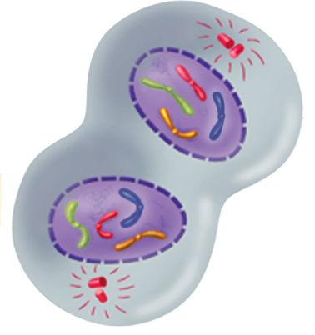
- What structures reaches the opposite end of the poles?
- Where are the newly formed chromatids located?
- What structure is reappearing?
- What type of cell is represented in the diagram?
- Cytokinesis begins and the ___________ and __________________ separate.
- What is the final product of cytokinesis?

Part 7
- What is the cytoplasm of the cell?
- TRUE OR FALSE: Most of the life processes takes place within the cytoplasm of the cell.
- Indicate the function of the following organelles:

- Mitochondria
- Endoplasmic reticulum
- Vacuole
- Ribosomes
- Centrioles

Part 8
- Name any three types of asexual reproduction (page 160) of textbook.
- Name two specialized cells that contain genetic information to produce a new organism.
- Is it possible for organisms to reproduce asexually and sexually? Give an example
- Name any two characteristics about cancer cells.
- A substance or energy that causes mutation is called a _______________________.
- Name three carcinogens.
Part 9
- What occurs during the G1 or First Growth Phase of the cell cycle?
- At the end of which phase of the cell cycle is the cell ready to start cell division?
- Interphase includes what three phases of the cell cycle?
- The series of events that cells go through as they grow and divide is called the _____________________.
- All of the following statements are false. What word(s) need to be changed to make the statements true?
- DNA replication takes place during the M phase (cell division) of the cell cycle.
- Cytokinesis usually occurs during anaphase of mitosis.
- During mitosis, sister chromatids separate from one another during metaphase.
- The two major stages of cell division include G₂ and prophase.
Part 10
- Name structures only found in animal cells and plant cells.
- These structures contain the green pigment chlorophyll.
- Plant cell walls are composed of a tough fiber called ___________________.
- Name the structures (A to E) labeled below.
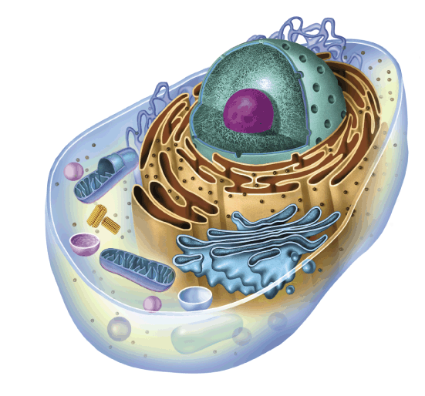
C
D
E
B
A
- What are organelles?

