BIO 112 – Section 7-2 Eukaryotic Cell Structure Assignment – Total Value 50 – March 21/18

Name: __________________________________________ DUE: Friday, MARCH 23/18

Part A – Label the following diagram using the word list below (use lines without arrows, please use a ruler to make your lines, and print the words clearly. Value 7
WORD LIST: chloroplast, smooth endoplasmic reticulum, nucleolus, mitochondrion, cell membrane, nuclear pore, cell wall
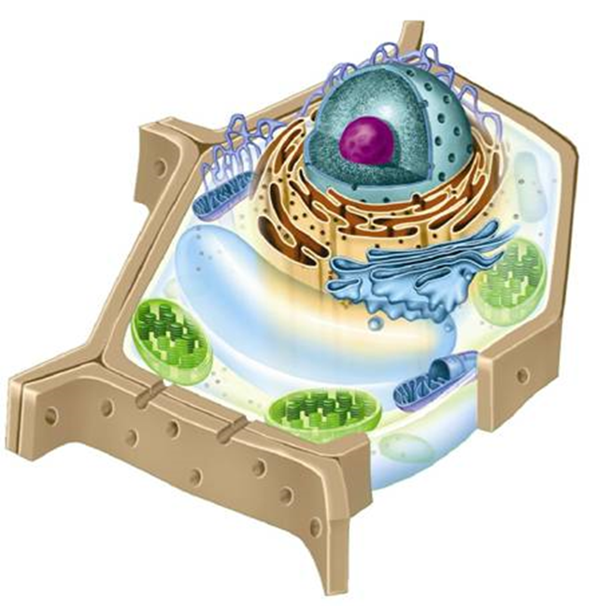

Part B – Short Answer Questions - Value 23

- Does the diagram above represent an animal cell or plant cell? Provide evidence (2 facts) to support your answer. Value 2

ANS: ___________________________________________________________________________

________________________________________________________________________________

- Compare the differences between animal and plant cells. Value 4

ANS: ___________________________________________________________________________

_________________________________________________________________________________

_________________________________________________________________________________
- State which organelle, in animal cells, replicates at the start of cell division and may help organize microtubule assembly. Value 1 ANS:_____________________________________________________________________
4. State the difference between the following terms: Value 2

ANS: chromatin -_____________________________________________________________________

ANS: chromosomes -__________________________________________________________________

- (a) The chloroplast is an example of a plastid. What is the function of this organelle? Value 1

ANS: ______________________________________________________________________________
___________________________________________________________________________________
___________________________________________________________________________________

- Name three unique characteristics or features of a chloroplast. Value 3

ANS: ______________________________________________________________________________
___________________________________________________________________________________
___________________________________________________________________________________
___________________________________________________________________________________

- What is the name given to uncoiled (or uncondensed) chromosomes? Value 1

ANS: ___________________________________________________________________________

- Cells that are active in protein synthesis are often packed with ____________________. Value 1

- The organelle named __________________________contains _________________ that perform specialized tasks, such as the synthesis of membrane lipids and detoxification of drugs. Value 2

- (a)____________________ is the name of the organelle that is filled with enzymes which break down lipids, carbohydrates, and proteins into small molecules that can be used by the rest of the cell.

- They also break down ____________________ that have outlived their usefulness. Value 2

- The _______________________________________modifies, sorts, and packages proteins and other materials from the endoplasmic reticulum for storage in the cell or secretion outside the cell. Value 1

- What is the difference between the composition and function of microfilaments and microtubules? Value 3
ANS: ______________________________________________________________________________

- Fill in the blanks. Indicate the term(s) to complete each sentence below. Value 20

- The two major parts of eukaryotic cells are _____________________ and _____________________.

- The assembly of proteins, commonly referred to as ___________________________________, occurs on ribosomes.

- When a cell divides, chromatin condenses to form into __________________________.

- The smooth ER produces a large amount of ___________________________.

- Vacuoles help maintain ________________________ in the cell.

- Chloroplast contains the green pigment _______________________.

- The function of the ____________________________ is to synthesize proteins.

- Chromatin consist of _____________ bonded to ________________________.

- The rough ER contains _________________________.

- The nucleus is the control center of the cell (which controls the cell’s ____________________).

- Mitochondria are organelles that convert the chemical __________________ stored in food into compounds that are more convenient for the cell to use.

- Centrioles are located near the nucleus and help to organize _____________________________.

- Centrioles are organelles found only in __________________cells.

- Cell or plasma membrane protects and _______________________ what materials enter and leave the cells in both plant and animal cells.

- Microtubules are hollow structures made up of proteins known as _____________________.

- Microfilaments are threadlike structures made up of the protein ____________________.

- A rigid structure that surrounds the cell membrane and protects, supports, and allows materials to pass into and out of the cell through pores is called the _______________________________.

- The site where lipid components of the cell membrane are assembled, along with proteins and other materials that are exported from the cell is the ___________________________________.
TOTAL VALUE 50

