SECTION 7-2 – EUKARYOTIC CELLS – SELF QUIZ
NAME: ________________________________________________ DATE: MARCH 19, 2018
- Label all of the structures of the following eukaryotic cell.
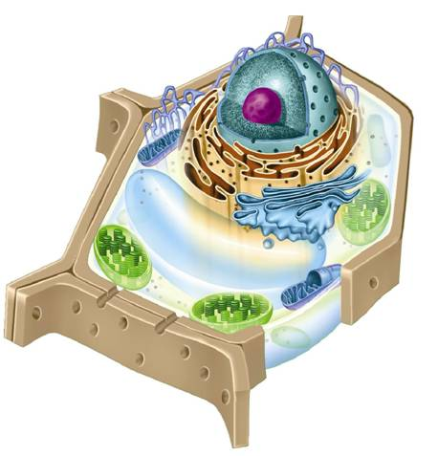
- What type of eukaryotic cell is represented above? Provide evidence (two facts) to support your answer.
- ___________________________________________________________________________

- ___________________________________________________________________________

- Fill in the blanks with the correct term(s).
- The portion outside the nucleus is called the _________________________.
- Specialized structures of a eukaryotic cell are called __________________________.
- The nucleus is composed of four main structures: they are the ____________________, __________________________________, ________________________________, and ________________________________.
- The granular material in the nucleus is called ____________________ which consists of ______________ and __________________.
- When a cell divides, chromatin condenses to form ______________________________.
- Plant and animal cells are examples of __________________________ cells
- DNA is stored mainly in the ____________________________.
- Two major parts of eukaryotic cells are the _______________________ and ________________________.

- What are the main functions of the nucleus?
- ___________________________________________________________________________

- ___________________________________________________________________________

Name: _____________________________________ March 20, 2018
NOTE: Complete the following in pencil!
- All of the following statements are FALSE. Identify (underline) the incorrect word(s) and provide the correct word(s) on the lines provided to make each statement true.

- Ribosome are small particles of DNA and protein are found throughout the cytoplasm which produce proteins by following coded instructions that come from the rough ER. (2)
___________________________________________________________________________

- The endoplasmic reticulum is where carbohydrate components of the cell membrane are assembled, along with DNA and other materials that are exported from the cell. (2)
___________________________________________________________________________

- Rough ER contains collections of enzymes that perform specialized tasks, such as synthesis of membrane lipids and detoxification of drugs. (1)
___________________________________________________________________________

- The Golgi apparatus can be referred to as Golgi complicated or tissue. (2)
___________________________________________________________________________

- The Golgi apparatus modifies, sorts, and packages proteins and other materials from the endoplasmic reticulum for secretion in the cell or storage outside the cell. (2)
___________________________________________________________________________

- Lysosomes are small organelles filled with enzymes which break down minerals, vitamins and proteins into small molecules that can be used by the rest of the cell. They also break down organs that have outlived their usefulness. (3)
___________________________________________________________________________

- Some cells contain saclike structures called vacuoles that store materials such as water, salts, proteins, and carbohydrates. In many plant cells there is a double large central vacuole filled with liquid. The pressure of this structure allows plants to produce heavy structures such as leaves and flowers. (2)
___________________________________________________________________________

- A single celled organism called the paramecium contains a continuous vacuole that pumps excess water out of the cell regulating homeopathy. (2)
___________________________________________________________________________

- Mitochondria convert the chemical energy stored in food into compounds that are more convenient for the cell to reuse. The outer membrane is folded up inside the organelle (cristae) provides a large surface area for the production of ADP (energy within a cell). (3)
___________________________________________________________________________

- Chloroplasts capture energy from sunlight and convert it into chemical energy in a process called chemosynthesis. Chloroplasts are surrounded by three membranes and contain the green pigment chlorophyll. (2)
___________________________________________________________________________

- Eukaryotic cells are given their shape and internal organization by the cytoskeleton. The cytoskeleton is a network of protein filaments that help the cell to maintain its shape and is also involved in movement. The cytoskeleton is made up of microfilaments and microtubules.
Indicate whether the following characteristics describe a microfilament or a microtubule.
- _____________________ Form extensive networks in some cells.
- _____________________ Are important in cell division.
- _____________________ Maintain cell shape.
- _____________________ Are threadlike structures made up of the protein actin.
- _____________________ Are hollow structures made up of proteins known as tubulins.
- _____________________ Build projections from the cell surface (cilia & flagella) that enable some cells to swim rapidly through liquids.
- _____________________ Produce a tough, flexible framework that supports the cell.
- _____________________ Helps some cells move.
- _____________________ Structures known as centrioles are formed from tubulin.
- _____________________ Sperm cells flagella (for example).

