Science 9 - Adopt an Element Project OUTLINE – Tuesday, October 16, 2018
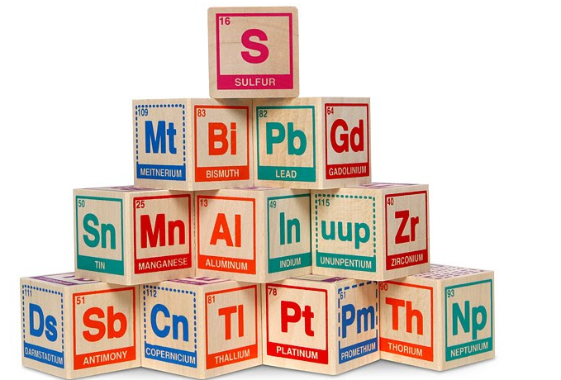
Name: ____________________________ DUE DATE: Tuesday, October 23, 2018
EACH ONE OF THE SIX SQUARES SHOULD BE 170 mm by 170 mm (with 10 mm boarder) – See sample sheet provided!

NOTE: STUDENTS MUST COMPLETE TWO SIDES OF THEIR SQUARES PER DAY
NOTE: IF NOT COMPLETED DURING CLASS TIME ONE MUST COMPLETE FOR HOMEWORK

Side 1 – Your Element
- This side of your cube will look like the element’s box on the periodic table.
- YOU MUST INCLUDE YOUR NAME ON THIS SIDE

Side 2 – Bohr Model
- Find or draw a Bohr model of your element showing protons, neutrons and electrons.
- Use a key or labels (for protons, neutrons, and electrons).
- Make sure your electrons are in the correct energy levels and protons and neutrons are visible in the nucleus.

Side 3 – Element Properties
- In bullet form, list the chemical properties of your element. (Include 3 - 5 properties).
- In bullet form, list the physical properties of your element. (Include 3 - 5 properties).
- Include at least one picture representing a chemical or physical property.
- Make sure you have a title for each set of properties.

Side 4 – History of the Element
- In paragraph form (5 -7 sentences), write the history of your element. You might include some of these topics: who discovered your element, when and where and how it was discovered, the importance of the element in the past.
- Include at least one picture showing historical information about the element.

Side 5 – Uses in Industry
- In paragraph form (5 – 7 sentences), describe how your element is used. You might include some of these topics: one or more uses, how the element is manufactured, costs of using your element, importance of your element to economies throughout the world.
- Include at least one picture showing how your element is used.

Side 6 – Fun and Fascinating Facts
- In bullet form, choose 3 - 5 interesting facts that you have not used elsewhere on your project.

RUBRIC ON BACK OF SHEET

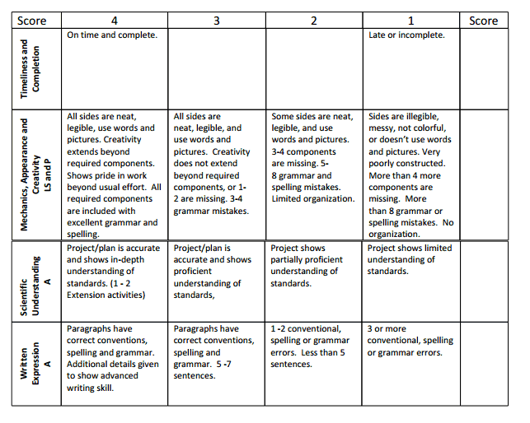
Rubric

