Social Wellness Assignment: #Selfie – April 15, 2019
DUE: WEDNESDAY, APRIL 17, 2019
PART 1: Social Wellness Self Assessments (will be added to portfolio)
- How Comfortable are you in Social Situations (explain)
- Social Support
PART 2: Examine the lyrics (on back of page) to the song, “Let Me Take a Selfie.”
  - Reflect on what the lyrics are portraying:
      - What is the message?
      - How does it make you feel?
PART 3: The evolution and significance of the “Selfie”
  - 1) Do a survey of 5 of your friends asking how many Selfies are on their phone?
      - Indicate the amount of selfies per person
  - 2) Without informing your participants that this is for a project ask 5 people to get a selfie with you and record their reaction to [again take mental notes so the experience can be as authentic as possible]:
    - Being asked? Are they willing to get a selfie right away?
    - Do they “prepare for the selfie?”
    - Did they ask you to take a different one? If so record their reason
    - Was the reaction different for boys and girls?
    - Did they ask you to post it on social media?
    - Any other observations.
  - 3) Reflect on your own “social footprint”.
 On Average, how many hours a day do you spend on Social Media?
 What social media sites are you a part of?
 What type of images / pages do you like & share?
 What impact does the time spent or images / text viewed have on your relationships? Opinion of yourself?

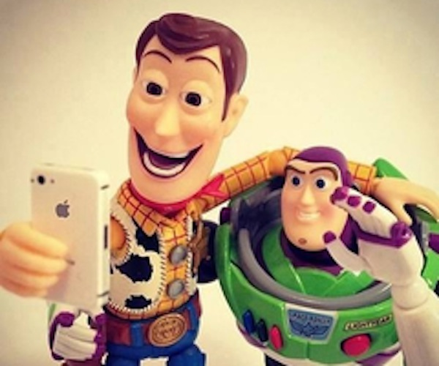
"#SELFIE"
~ The Chainsmokers
When Jason was at the table
I kept on seeing him look at me while he was with that other girl
Do you think he was just doing that to make me jealous?
Because he was totally texting me all night last night
And I don't know if it's a booty call or not
So... like what do you think?
Did you think that girl was pretty?
How did that girl even get in here?
Do you see her?
She's so short and that dress is so tacky
Who wears Cheetah?
It's not even summer, why does the DJ keep on playing "Summertime Sadness"?
After we go to the bathroom, can we go smoke a cigarette?
I really need one
But first,
Let me take a selfie
Can you guys help me pick a filter?
I don't know if I should go with XX Pro or Valencia
I wanna look tan
What should my caption be?
I want it to be clever
How about "Livin' with my bitches, hashtag LIVE"
I only got 10 likes in the last 5 minutes
Do you think I should take it down?
Let me take another selfie
Wait, pause, Jason just liked my selfie
What a creep
Is that guy sleeping over there?
Yeah, the one next to the girl with no shoes on
That's so ratchet
That girl is such a fake model
She definitely bought all her Instagram followers
Who goes out on Mondays?
OK, let's go take some shots
Oh no, ugh I feel like I'm gonna throw up
Oh wait, never mind I'm fine
Let's go dance
There's no vodka at this table
Do you know anyone else here?
Oh my god, Jason just texted me
Should I go home with him?
I guess I took a good selfie

