Biology 122 – DNA Replication Computer Lab Assignment – October 31, 2019
Web Site: Phschool.com Code: cbp-4122 DUE: November 1, 2019
Name: ______________________________________________
Section A
Complete the following sentences with the missing word or words in the spaces provided:
Before a cell divides, it its in a copying process called . This process ensures that each resulting cell will have a _________________________ of DNA molecules.
DNA replication is carried out by a _______________________________. These enzymes __________ a molecule of DNA. The sites where the __________________ and ___________________ occur are called the _______________________________________.
When ________________________________ between the base pairs are _______________, the two strands of DNA ________________. Each strand serves as a _____________________ for the attachment of __________________________________. Replication proceeds in _______________________________ until each chromosome is ___________________________.
The principal enzyme involved in DNA replication is called __________________________________. The rules of base pairing make it possible to _____________________ the base sequence of the ____________________ strand. Guanine always bonds with ______________________ and thymine always bonds with _____________________, these are said to be ________________________ bases.
DNA continues to replicate in _____________ directions.
In addition to adding complementary bases to the original strands, DNA polymerase also ____________________ each ____________________ strand, helping to maximize the odds that each molecule is a _______________copy of the original _________. In the end, there are to new complementary strands of DNA, and the cell is ready to divide.
End result of replication is _____________________ DNA strands each with a(n) _______________________________ of DNA and a ___________________________new strand of DNA.

Complete the following strand by providing the complementary base pairs that are missing on both strands indicated below (starting at the arrows provided):
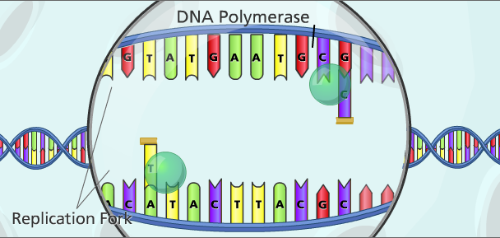
Section B – Use textbook and/or internet to complete the following questions.
NOTE: If not enough space provided, please answer your responses on your own paper.
- Describe the structure and components of DNA.
ANS:

- What are nucleotides?
ANS:
- What is a nucleosome?
ANS:
- What are histones?
ANS:
- What is helicase?
ANS:

- What is the role of helicase in DNA replication? Why is their role so important during DNA replication?
ANS:
- Where does DNA replication take place in eukaryotic cells?
ANS:
- Define the term gene.
ANS:
- The first step of DNA replication is to copy part of the DNA sequence into a new ANS:

- In a DNA strand, the letters A, T, C, and G represents .

7. What is a purine? Which nitrogen bases represents purines?
ANS:

8. What is a pyrimidine? Which nitrogen bases represents pyrimidines?
ANS:

