Section 6.2 – **Relationship between slope and angle of elevation February 26, 2020
Name: _________________________________________
Section 6.2
- (a) FIRST determine the slope (rise/run) in lowest terms for each triangle below.
(b) SECOND determine the tangent ratio of angle A (2nd TAN) to the nearest degree for each triangle below.

- c.
25 cm
6 in
A
12 in
A
15 cm

Slope = rise = _______ = ________ Slope = rise = _______ = ________
Run run
Slope as decimal = _______________ Slope as a decimal = _________________
Angle A (in degrees) = ___________ Angle A (in degrees) = ___________

50 m
- d.
A
5 m
30 m
A
15 m

Slope = rise = _______ = ________ Slope = rise = _______ = ________
Run run
Slope as decimal = _______________ Slope as a decimal = _________________
Angle A (in degrees) = ___________ Angle A (in degrees) = ___________

- Determine the slope (reduced fraction) of each line. REMEMBER – use any two points on the line!
- c.
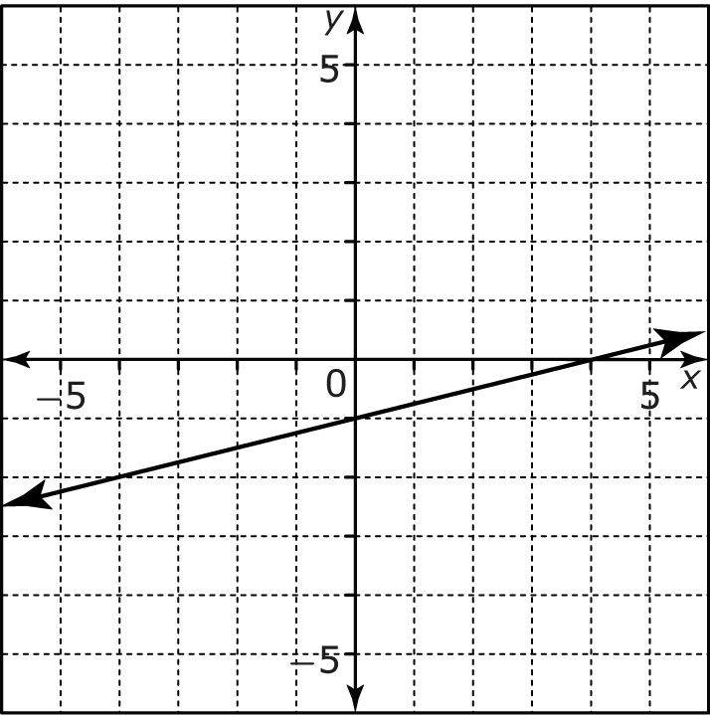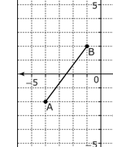
Slope = _____ = _____ Slope = _____ = _____

- d.
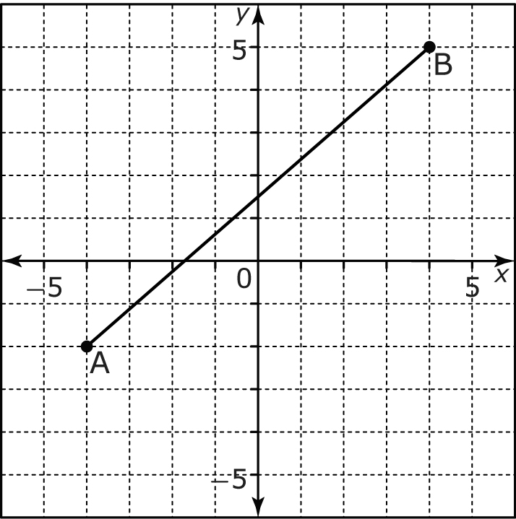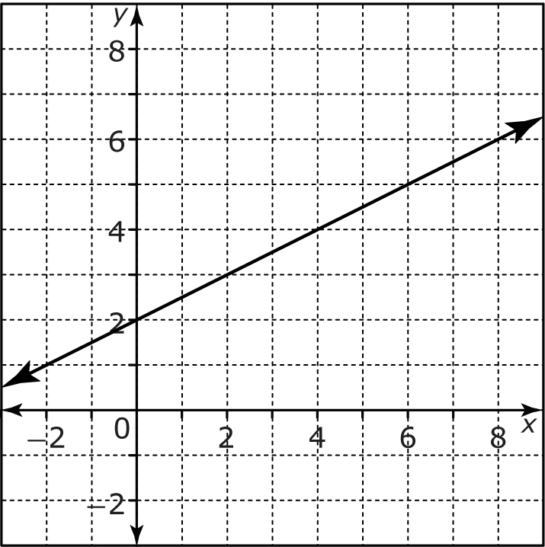
Slope = _____ = _____ Slope = _____ = _____

- Determine the tangent ratio (in degrees) of each line in question #2 above.

- __________________________________ c. __________________________________

- __________________________________ d.__________________________________

- The bottom of a ladder is 1.5 m from a house. The angle between the ladder and the ground is 60 degrees. How far up the house does the ladder reach? Round your answer to the nearest tenth of a meter. First, draw a diagram & include labels then solve for the unknown (X) below.

TAN 60 degrees = ___X___
1.5 m
X
60⁰

1.5 m

- From a boat 120m away, the angle of elevation of the top of a lighthouse is 42 degrees. Determine the height of the top of the lighthouse from sea level. Express your answer to the nearest tenth of a meter. First, draw a diagram with labels and then solve for the unknown (X).
TAN 42 degrees = _ X___
120 m
X
42⁰
boat
120 m

- Determine the angle of elevation in degrees of a road with each grade (provided as a percentage below).
Example: 15% = 15 divided by 100 = .15
Shift or 2nd TAN .15 = 8.53 degrees = 9 degrees
- 6%
6% = 6 divided by 100 = _______
Shift/2nd Tan (answer above) ___________ = ___________ degrees

- 25%

25% = 25 divided by 100 = _______

Shift/2nd Tan (answer above) ___________ = ___________ degrees

- Indicate the relationship between the grade of a road and the angle of elevation. Provide an example.
The ______________ the grade of a road, the ____________________ the angle of elevation.
Example:

- In class, we identified items in a house that would have a zero slope and undefined slopes. What is the importance of both of these slopes to real life situations? Provide two examples.

Items with zero slope in a house: _____________________________________________

Importance of items with zero slope: _____________________________________________

Items with undefined slope in a house: ___________________________________________

Importance of items with undefined slope: _________________________________________

- Carpenters must follow guidelines when building stairs. The rule is that for every 250 mm of run there should be 200 mm rise. Chad is building a set of stairs. Each tread will have a run of 10 inches and a rise of 8 inches. Will his stairs meet the requirements? Explain

Slope = rise divided by run

Slope =

- Describe a road with a 0 % grade. State some effects this would have on driving.
NOTE: Compared to a downward or upward slope of road.

The effects of a zero percent grade on a road would include:
(1) ___________________________________________________________________
(2) ___________________________________________________________________

END OF SECTION 6.2

