Compound Light Microscope – Name: _________________________ Date: Feb 20, 2018
Page 538 of textbook – Learning the name, function, and location of each of the microscope’s parts necessary for proper use in the lab.
- Identify the functions of the following parts of a compound (light) microscope indicate below.
Parts of the Microscope | Function
stage
clips (stage clips)
diaphragm
objective lenses
low power objective lens (4X)
medium power objective lens (10X)
high power objective lens (40X)
revolving nosepiece
body tube
ocular lens (eyepiece)
coarse-adjustment knob
fine-adjustment knob
condenser lens
- Review procedures outlined for preparing a wet mount on page 539.
- Practice Sheet - Label the following diagram using the list provided below (utilize textbook page 538 if necessary) in preparation for the onion lab soon.
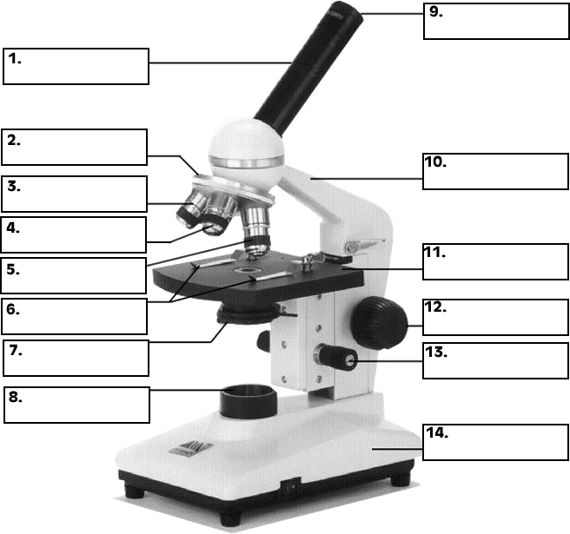

A - medium power objective F - body tube K - base
B - coarse adjustment knob G - diaphragm L - stage clips
C - fine adjustment knob H - high-power objective M - stage
D - illuminator/light I - low-power objective N - arm
E - revolving nosepiece J - eyepiece or ocular O – condenser lens

