**Chapter 6.1 and 6.2 PRETEST REVIEW – SLOPE and ANGLE OF ELEVATION**

NAME: ___________________________________________ DATE: **March 30, 2017**

**Section 6.1: Slope**

1. Show the following in **lowest terms (as a fraction)**:
2. 6 = b. 6 = c. 2 = d. 12 =

12 30 14 16

**2.** What is the **slope** of the line whose **rise is 4** and the **run is 100**?

**A** 5

**B** 0.8

**C**  or .3333

**D**  or .08

1. Solve each proportion.

a) 

b) 2:20 = 12: X

c) 32: X = 16:4

D) 15:3 = X: 2

e) X: 18 = 2:3

h) 30: X = 10:5

1. 20:1 = 100

**4.** Determine the slope of each line indicated below.



**I**

**J**

**L**

**K**

**H**

**G**

**F**

**E**

**D**

**C**

**B**

**A**

**Line AB =**

**Line CD =**

**Line EF =**

**Line GH =**

**Line IJ =**

**Line KL=**

**Which line has the steepest slope? ANS: _____________________________**

**Which line has the least slope? ANS: __________________________**

**Page 262**

**5.** Slope is defined as the ___________________ of a line.

**6.** A line has a slope of 24:16 and another line has a slope of 36:6. Prove which line has a steeper slope by calculating the decimal value or whole number of each slope.

**7.** TRUE OR FALSE: When a slope is constant (like a staircase) it means the value of the slope is always the same.

1. Indicate what makes a line on a graph steeper than another line on the same graph? Use a diagram (graph) to aid in your explanation.

**SECTION 6.2**

1. Determine the **tangent ratio of ∠A** in each triangle.

**NOTE: 2nd Tan = degrees**

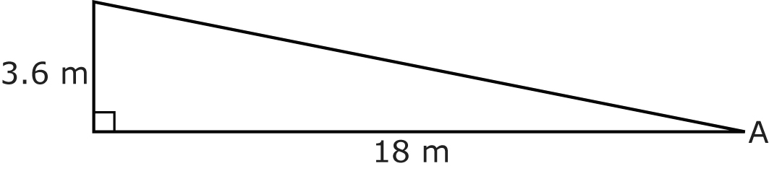

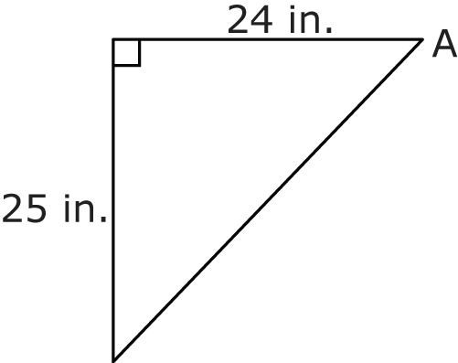

1. What **angle (angle of elevation)** does a ramp with a slope of 1:15 make with the ground?
2. A ramp has a steepness of **1 in**. for every **10 in**. of run.
3. For the ramp to rise **1 ft**, how far along the ground should it be? Draw diagram and show units used. **NOTE: 1 ft = 12 inches**
4. What is the **angle of elevation** of the ramp?
5. A driveway rises 6 inches over 90 inches along the ground. What is the **grade**   
   of the driveway?
6. Determine using the **rise and run** given of each road below, determine the slope as a fraction, slope as a decimal, and the percent (grade) of the roads.

|  |  |  |  |  |  |
| --- | --- | --- | --- | --- | --- |
| Road | Rise | Run | Slope as a Fraction | Slope as  a Decimal | Percent (Grade) |
| Mathematics Avenue | 12 | 50 |  |  |  |
| Biology Boulevard | 25 | 75 |  |  |  |