Biology 12 – Pedigree – Phschool.com code: cbp-4141 ASSIGNMENT (Recessive Trait – Value 21)
Name: ___________________________________Period: ______ Date: October 27, 2017
Recessive Trait:
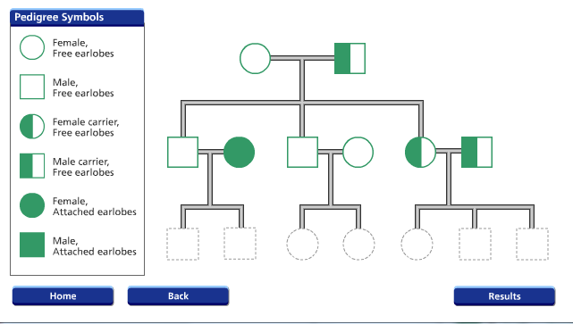
Sex linked:
