Mitosis Worksheet and Diagram Identification
Name: ______________________________________________ March 20, 2018
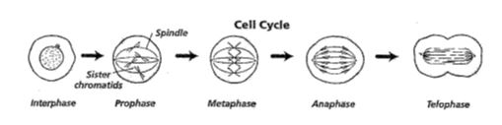
- Chromosomes move to the middle of the cell on the spindles during what phase?
ANS: ________________________________

- (a) What are sister chromatids?
ANS: __________________________________________________________________

(b) When do they separate?
ANS: __________________________________________________________________

- During which phase do chromosomes first become visible during mitosis?
ANS: __________________________________________________________________

- During what phase does cytokinesis occur?
ANS: ___________________________________________________________________
Complete the table by checking the correct column for each statement.
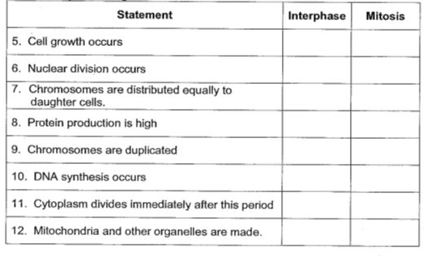
The following are NOT in the correct order. Answer the questions below based on the diagrams provided.

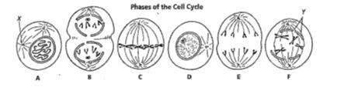
13. Which cell is in metaphase (provide letter of diagram)? ANS: ____________

14. Cells A and F show an early and late stage of the same phase of mitosis. What phase is it?
ANS: ____________________________________________

15. In cell A, what is the structure labeled X? ANS: ______________________

16. In cell F, what is the structure labeled Y? ANS: ______________________

17. Which cell is not a phase of mitosis? ANS: __________________________

18. What two main changes are taking place in cell B?
ANS: (a) ____________________________________________________________

ANS: (b) ____________________________________________________________

19. Sequence the six diagrams in order from first to last (using the letters provided).
ANS: _______________________________________________________________

20. What is the end product of mitosis?
ANS: _______________________________________________________________

21. What is the main difference between cytokinesis in plants and animals?
ANS:
Animals: _______________________________________________________________
Plants: _______________________________________________________________

