INTERPOLATING AND EXTRAPOLATING A LINE GRAPH ASSIGNMENT – VALUE 70
Name: ___________________________________ Date: May 7, 2018 DUE: MAY 8, 2018
INSTRUCTIONS: For each line graph questions below (#1, 3, 5, and 6) answer by showing interpolating and extrapolating lines (DOTTED LINES USING A RULER) on the graph as shown below IN PENCIL ONLY. One point for each line and one point for each estimated values for each.
- Answer the following questions based on the line graph below. Value 10

- How tall (cm) is the plant on November 20th? ______________________________
- How tall (cm) is the plant on December 2nd? ______________________________
- On what date does the plant reach a height of 28 cm? _____________________________
- On what date does the plant reach a height of 55 cm? _____________________________
- Predict the height of the plant on December 9th? _____________________________
- Complete the following sentences by finding the missing terms below. Value 5
trend interpolate continuous extrapolate downward
(a) _________________________ is an estimate of a value that falls inside a known range or graph values.
(b) A _____________________ is the general direction in which values in a data set tend to move (upward or downward).
(c) _________________________ is an estimate of a value that falls outside a known range or graph values.
(d) Data on a graph that are connected is __________________________.
(e) Trends on a graph shows the general direction of a line and can be represented as an upward (increasing) trend, a _______________ (or decreasing) trend, or a line that is constant (non-changing).

- From the data on the chart, the following graph was drawn. Value 10

Year | Number of Cars
2000 yr | 2500
2002 yr | 2800
2004 yr | 3100
2006 yr | 3400
2008 yr | 3650
2010 yr | 3800
2012 yr | 4100

- Indicate the trend of car sales from the line graph (downward, upward or constant). ______________________________trend

- Interpolate to predict the number of cars sold in the year 2001. _________________cars

- Interpolate to predict the number of cars sold in the year 2007. _________________cars

- Extrapolate to predict the number of cars sold in the year 2014. _________________cars

- Extrapolate to predict the number of cars sold in the year 2016. ________________ cars

- Given below is a line graph example with questions, which show the annual food grain production from 1992 to 1997. Refer to the graph & answer the questions based on the line graph provided. Select one correct answer for (a) and (b) below. Value 2
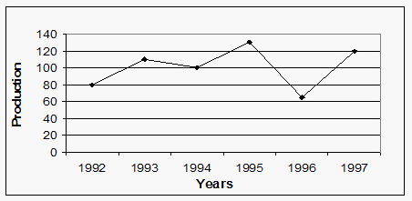
- The average (sum of the numbers divided by how many numbers are being averaged) production of 1994 and 1996 was approximately equal to production of which year?

A. 1996

B. 1992

C.1995

D. 1994
(b) The maximum increase in food grain production has been in the year:

A. 1997

B. 1996
C.1995

D. 1994
- Provided below is a line graph, which show the average stem length (cm) of a plant over a fifteen (15) day period. Answer the questions below. Value 10
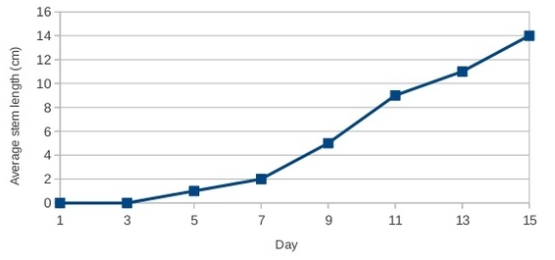
- Interpolate to predict the average stem length of the plant on the 8th day? ______________cm
- Interpolate to predict the average stem length of the plant on the 14th day? ______________cm
- Extrapolate to predict the average stem length of the plant on the 17th day? ______________cm
- Interpolate to predict on which day the average stem length was 9 cm? ______________day
- Extrapolate to predict on which day the average stem length was 16 cm? ______________day
6. Complete the following chart (indicate the weight in pounds missing or the month) based on the line graph provided below. NOTE: Show interpolating and extrapolating lines (dotted lines)! Value 10
Weight in pounds | Month
7 lbs.
17 lbs.
 | 8
30 lbs.
 | 10
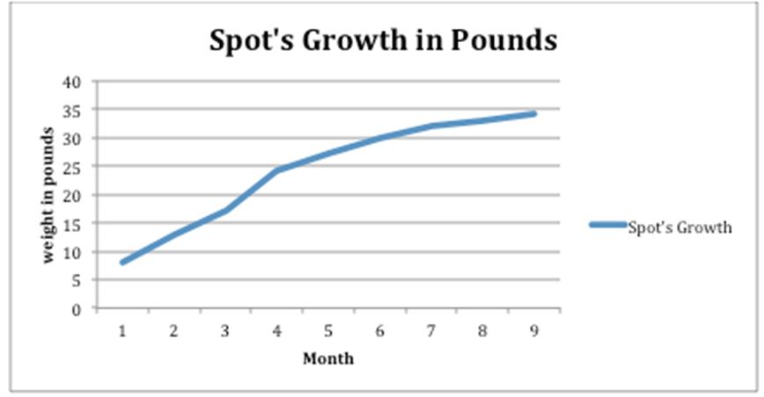
- From the following chart provided below, graph the following information on the graph provided.
- First label (on the X-axis) the title Age /Months (print only). Value 1
- Second graph (on the X-axis) the values of German Shepherd Age/Months (first column values). Value 7
- Third label (on the Y-axis) the title Male/Female average weight/kg (print only). Value 1
- Fourth graph the Male average weights (third column values) in kg using a pencil. Value 7
- Last graph (on the Y-axis) the Female average weight in kg (fifth column values) using another contrasting color (such as dark blue or dark green or red, any color that is different and easy to read on the graph, avoid light colors please). Value 7
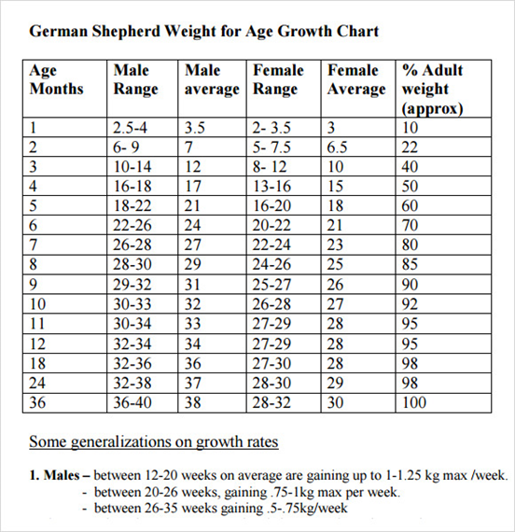
German Shepherd Weight for Age Growth

