INTERPOLATING & EXTRAPOLATING A LINE GRAPH ASSIGNMENT (MOD) – VALUE 55
Name: ___________________________________ Date: May 7, 2018 DUE: MAY 8, 2018
INSTRUCTIONS: For each line graph questions below (#1 and 5) answer by showing interpolating and extrapolating lines (DOTTED LINES USING A RULER) on the graph as shown below IN PENCIL ONLY. One point for each line and one point for each estimated values for each.
- Answer the following questions based on the line graph below. Value 8

- How tall (cm) is the plant on November 19th? ______________________________
- On what date does the plant reach a height of 45 cm? _____________________________
- On what date does the plant reach a height of 52 cm? _____________________________
- Predict the height of the plant on December 9th? _____________________________

- Complete the following sentences by finding the missing terms below. Value 5
trend interpolate continuous extrapolate downward
(a) _________________________ is an estimate of a value that falls inside a known range or graph values.
(b) A _____________________ is the general direction in which values in a data set tend to move (upward or downward).
(c) _________________________ is an estimate of a value that falls outside a known range or graph values.
(d) Data on a graph that are connected is __________________________.
(e) Trends on a graph shows the general direction of a line and can be represented as an upward (increasing) trend, a _______________ (or decreasing) trend, or a line that is constant (non-changing).

- From the data on the chart, graph the values provided. Then connect the values to show the trend of the line (upward or downward). Value 7

Year | Number of Cars
2000 yr | 2500
2002 yr | 2800
2004 yr | 3100
2006 yr | 3400
2008 yr | 3600
2010 yr | 3800
2012 yr | 4100

- Given below is a line graph example with questions, which show the annual food grain production from 1992 to 1997. Refer to the graph & answer the questions based on the line graph provided. Select one correct answer for (a) and (b) below. Value 3
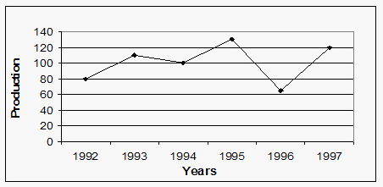

- In what year did the production of grains reach 100?

A. 1996

B. 1992

C.1995

D. 1994
(b) What was the total annual grain production in 1997?

A. 130

B. 120
C.110

D. 80

(c) In which year was the annual grain production the most (or greatest)?

- 1996

- 1997
- 1995

- 1992

- Provided below is a line graph, which show the average stem length (cm) of a plant over a fifteen (15) day period. Answer the questions below. Value 10
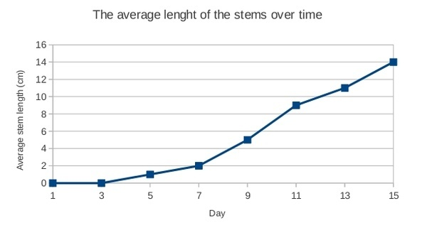
- Interpolate to predict the average stem length of the plant on the 7th day? ______________cm
- Interpolate to predict the average stem length of the plant on the 11th day? ______________cm
- Interpolate to predict the average stem length of the plant on the 5th day? ______________cm
- Interpolate to predict on which day the average stem length was 14 cm? ______________day
- Extrapolate to predict on which day the average stem length was 16 cm? ______________day
6. Complete the following chart (indicate the temperature missing OR the date/day) based on the line graph provided below. NOTE: Show interpolating and extrapolating lines (dotted lines)! Value 5
Date/Day | Temperature (Cº)
Fri 13/10
Tues 17/10.
 | 27
Sun 15/10
 | 23
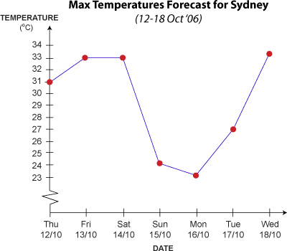

- From the following chart provided below compares test scores in various subjects of a student. Graph the information on the graph provided.
- First label (on the X-axis) the title Subjects (print only). Value 1
- Second graph (on the X-axis) the names of the subjects in the order provided (first column values). Equally space the names of the subjects. Value 5
- Third label (on the Y-axis) the Test Scores (print only). Value 1
- Fourth graph the test scores by 10’s (from zero to 100) for each vertical line on the Y-axis using a pencil. Value 5
- Last graph (on the Y-axis) test scores indicated below then connect the values with a line using a ruler (use a color, dark color, to connect the line on the graph provided). Value 5
Subjects | Test Scores
English | 70
Math | 75
Social Studies | 65
Science | 82
Physical Education | 90

Test Scores on Different Subjects

