Section 12-1 and 12-2 Homework Assignment – Complete by November 12, 2019
Section 12-1: DNA - Relationship between DNA and Genes – November 6, 2019
Name:
PART A - Griffith and Transformation (pages 287-289)
1. Frederick Griffith wanted to learn how certain types of ____________________ produce _______________________________.

2. The strain of bacteria that caused pneumonia grew into colonies
on culture plates; harmless bacteria produced colonies with edges.

3. Circle the letter(s) of each sentence that is true about Griffith’s experiment.
a. Mice injected with bacteria from smooth colonies died.
b. Mice injected with bacteria from rough colonies died.
c. Mice injected with heat-killed bacteria from smooth colonies died.
d. Mice injected with a mixture of bacteria from heat-killed smooth colonies and live
rough colonies died.
4. What result from Griffith’s experiment suggested that the cause of pneumonia was not a
chemical poison released by the disease-causing bacteria?

5. is the process by which one strain of changes into another.

6. What hypothesis did Griffith form from the results of his experiments?
Griffith hypothesized that some factor, which might be a , was transferred from the bacteria cells into the live cells.
Avery and DNA (page 289)
7. Is the following sentence true or false? Avery and his colleagues thought that the
molecule required in transformation might also be the molecule of the gene.

8. Complete the description below of how Avery and his group determined which molecule was most important for transformation.
They treated the extract of bacteria with that destroyed proteins, lipids, carbohydrates and other molecules, but transformation still occurred. These molecules were NOT responsible for transformation.
© Pearson Education, Inc., publishing as Pearson Prentice Hall.
66

9. Transformation did not occur when was destroyed.

10. Avery concluded from his experiments that was the transforming . . Value 2
The Hershey-Chase Experiment (pages 289-290)
11. A bacteriophage is a that infects .

12. Circle the letter(s) of each part that makes up a bacteriophage.
a. lipid coat c. carbohydrate core
b. protein coat d. DNA core
13. What happens when a bacteriophage infects a bacterial cell?
The bacteriophasge injects its ____________ into the cell. The viral genes act to produce many new bacteriophages, which ____________________ out when the cell splits open.

14. How would Hershey and Chase learn whether genes were made of protein or DNA?
If they could determine which _________________ of the virus entered the infecte cell, tey would learn whether genes were made of __________________ or DNA.

15. The results Hershey and Chase observed was that nearly all of the in the bacteria was from , the marker found in DNA.

16. Hershey and Chase concluded that the genetic material of the bacteriophage was ____________.

PART B - The Components and Structure of DNA (pages 291-294)

- The three critical things that genes were known to do include:
- Genes had to carry information from one generation to the next.
- Genes are not easily copied.
- Genes had to determine the heritable characteristics of organisms.
- Genes had to be easily copied.

- What is the makeup of a nucleotide?

- A four-carbon sugar
- A phosphate group
- A nitrogenous base
- A five-carbon sugar
- All of the following statements are false. Replace the underlined word(s) with the correct word(s) to make the statement true.

Example: DNA is made of ribonucleic acids. ANS: DNA is made of nucleotides.

- Adenine and cytosine are examples of purines. ANS: _____________________

- Guanine and thymine are examples pyrimidines. ANS: _____________________

- Adenine and guanine are smaller molecules than cytosine and thymine because they have one ring in their structure. ANS: ___________________________________

- Adenine, guanine, cytosine, and thymine are four kinds of nucleic acids or bases in DNA. ANS: _____________________________

- The backbone of a DNA chain is form by sugar (oxyribose) and nitrogen groups of each nucleotide. ANS: _______________________________________

- DNA is a long molecule made up of units called nucleolus and are joined together in any specific order (any sequence of bases is possible). ANS: _____________________

- According to the principle of base pairing, nitrogen bonds could form only between adenine and thymine. ANS: _____________________

- According to Chargaff’s rules, the percentages of cytosine are equal to those of thymine and the percentages of adenine are equal to those of guanine in the DNA molecule. ANS: ________________________________

- Identify the components of a nucleotide in the diagram below and label the bases as purines or pyrimidines.

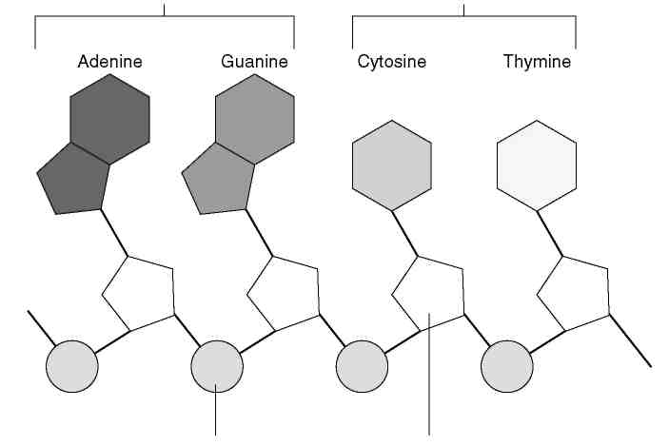

- Rosalind Franklin’s work with X-ray diffraction showed that the DNA molecule is
shaped like a (an) and contains strands.

6. How did Francis Crick and James Watson try to understand the structure of DNA?

7. Watson and Crick describe the structure of DNA as a (2 words), which two strands were wound around each other.

8. Label the following diagram of a DNA double helix model.

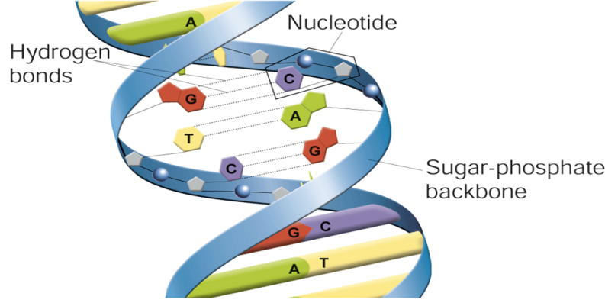

BONUS: DNA is a long molecule made of ________________ called nucleotides.
*Term is NOT in textbook!

PART C - Section 12-2 Chromosomes and DNA Replication
DNA and Chromosomes (pages 295-296)
1. In prokaryotic cells, the location of DNA is in the _______________________.
2. Is the following sentence true or false? Most prokaryotes contain a single, circular
DNA molecule. ______________
3. Eurkaryotic DNA is generally located in the cellin the form of a
number of chromosomes.
4. Is the following sentence true or false? All organisms have the same number of
chromosomes. _______________
5. Is the following sentence true or false? The E. coli chromosome is longer than the
diameter of an individual E. coli bacterium. ________________
6. Circle the letter(s) of each sentence that is true about chromosome structure.
a. The DNA in eukaryotic cells is very loosely packed.
b. Prokaryotic cells contain more DNA than eukaryotic cells.
c. A human cell contains more than 1 meter of DNA.
d. The DNA of the smallest human chromosome is nearly 10 times as long as many
bacterial chromosomes.
7. Eukaryotic chromosomes contain both DNA and protein, packed together to form
____________________________.
8. True or False: Histones are proteins around which DNA is tightly coiled.
9. Why are individual chromosomes visible only during mitosis?
__________________________________________________________________________________________
__________________________________________________________________________________________
__________________________________________________________________________________________
- Is the following sentence true or false? Changes in chromatin structure and histone-DNA binding are associated with changes in gene activity. _______________

- What are nucleosomes? What do nucleosomes do?

____________________________________________________________________________________________

DNA Replication (pages 297-299)
12. What occurs during the process of replication?
___________________________________________________________________________________________
___________________________________________________________________________________________

13. Complete the flowchart to describe the process of DNA replication.
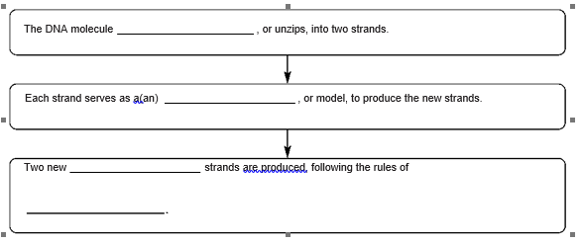
14. Is the following sentence true or false? In eukaryotic chromosomes, DNA replication
begins at a single point in the chromosome and proceeds in two directions. _______________

- The sites where DNA replication and separation occurs are call ___________________________.

- What occurs when a molecule of DNA is “unzipped”?
__________________________________________________________________________________________
__________________________________________________________________________________________
__________________________________________________________________________________________
17. What is the complementary strand of bases for a strand with the bases TACGTT?
__________________________________________________________________________________________
- Is the following sentence true or false? Each DNA molecule resulting from replication
has one original strand and one new strand. _______________

19. List two major roles of DNA polymerase in the process of DNA replication.
a. ________________________________________________________________________

b. _________________________________________________________________________

_________________________________________________________________________

