Cell Structure and Function Assignment Questions – Science 9 – Value 55 – Feb 16/18
Name: _________________________________ DUE: TUESDAY, February 20, 2018

- All living things are composed of ___________________________.

- All cells are surrounded by a thin, flexible barrier known as the _________________ or ____________________________ membrane.

- Name three functions of the cell membrane. (1) _______________________________________________________________________ (2) _______________________________________________________________________
(3) _______________________________________________________________________

- ________________________ is the organelle responsible to break down glucose (sugar) to provide the cell with energy.

- ________________________are the structures found scattered throughout the cytoplasm and aid in the making of proteins.

- __________________________________________________is the structure which contains many ribosomes attached to it.

- ____________________________ is the organelle found in plant cell which contains the green pigment chlorophyll.

- Both of these structures are found in both plant and animal cells. ANS: ______________________________________________________________

- Indicate which structure(s) is not found in plant cells but are only found in animal cells. ANS: ________________________________________

- Indicate which structure(s) is not found in animal cells but are only found in plant cells. ANS: ______________________________________________________________

- SHORT ANSWER – PLEASE ANSWER IN CLEAR FULL SENTENCES
- What are organelles? (Provide a clear written sentence)

ANS: ______________________________________________________________________

____________________________________________________________________________

- What is the cell wall composed (made of)?

ANS: _______________________________________________________________________

- What is the main function of the nucleus of a cell?

ANS: _______________________________________________________________________

____________________________________________________________________________

- Circle the letters of each structure that animal cells contain below.
- Chloroplast
- Centrioles
- Mitochondria
- Endoplasmic reticulum

- Circle the letters of each structure that plant cells contain below.
- Cell wall
- Endoplasmic reticulum
- Centrioles
- Chloroplast

III. FILL IN THE BLANKS - Fill in the blanks using the terms in the word list below.
WORD LIST:
vacuole lipids shape multicellular chromosomes
organelles support proteins protection mitochondria

- What make one cell different from another are the cell _______________________ which are small structures in the cytoplasm with specialized jobs.

- The cell membrane is composed (made of) ________________ and _______________.

- Genetic information is organized into threadlike structures called ________________________.

- A _______________________ is a large liquid-filled sac like structures that stores materials such as water, salts, proteins and carbohydrates.

- They ___________________________________ are often called the powerhouse of the cell.

- Organisms composed (made of) many cells are called ______________________________.

- The cell wall provides _________________, _________________, and ________________

- TRUE OR FALSE – Circle one correct response for each statement below.

- ( TRUE / FALSE ) Animal and plant cells share many organelles common to each other and those not common.

- ( TRUE / FALSE ) New cells are produced from non-living cells.

- ( TRUE / FALSE ) The cell membrane is not a living part of the cell.

- ( TRUE / FALSE ) The cell wall is not a living part of the cell.

- ( TRUE / FALSE ) Organelles within cells have specialized jobs.

- ( TRUE / FALSE ) All cells have the same function.

- ( TRUE / FALSE ) Cells are the basic units of structure and function in living things.

- ( TRUE / FALSE ) Cells that are one celled are organisms that are unicellular.

- ( TRUE / FALSE ) Genetic information is organized into threadlike structures called chromosomes.

- ( TRUE / FALSE ) The cell membrane is found in both the animal and plant cell.

- MATCHING - Match the organelle listed below with its proper description.
Organelle
Description
a. The green pigment needed to carry out photosynthesis to make sugars (food).
b. Two small structures found near the nucleus are involved in cell reproduction.
c. Uses energy from food (glucose) to make high-energy compounds to provide the cell with energy.
d. Saclike structure that stores materials such as water, salts, proteins, and carbohydrates.
e. To assist with the management or the movement of substances within the cell (highway system).

_____ 1. Endoplasmic reticulum
_____ 2. Vacuole
_____ 3. Centrioles
_____ 4. Mitochondrion
_____ 5. Chlorophyll

- LABELING - Label the following using the capital letters (A to H only). Place CAPITAL LETTERS IN THE BOXES PROVIDED next to the organelles in the diagram below.
WORD LIST:
- mitochondrion (B) rough endoplasmic reticulum (C) Golgi apparatus
(D) Cell membrane (E) nucleolus (F) nuclear envelope
(G) Ribosome (free) (H) centrioles

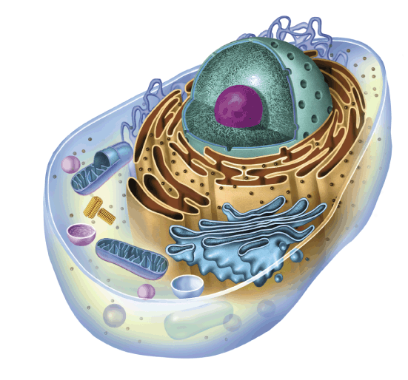

- CELLS
(A) What type of cell is indicated above? ______________________________
- Provide evidence (two reasons) to support your answer below.
Reason 1: _____________________________________________________________________________
_____________________________________________________________________________
Reason 2: _____________________________________________________________________________
_____________________________________________________________________________DUE: February 20, 2018

