Crisis Help Lines

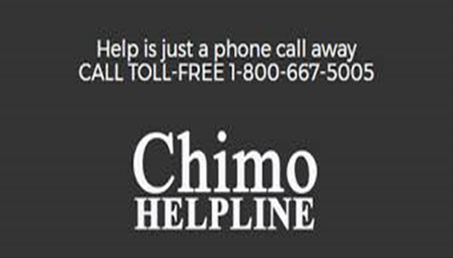

Chimo is a provincial crisis phone line, accessible 24 hours a day, 365 days a year to all residents of New Brunswick.
Our mission is to serve our community by providing a competent level of crisis intervention, referrals and vital information in a caring, confidential manner.
​
We can help you by providing a listening ear, helpful information, crisis intervention and referrals to resources in the province of N.B.

Did you know?  Chimo is an Inuit word that means friendship.​  ​  ​We are:  - Toll Free Telephone Number  - Confidential  - Non-Judgmental  - Supportive  - Bilingual | We are committed to helping with any issue:  - Thoughts of Suicide  - Emotional Distress  - Anxiety  - General Information/resources  - Loneliness  - Relationships  - Depression  - Mental Health

Contact Information – 1-800-667-5005 (toll free)
1-506-450-4357 (crisis line)
Live Chat from 5pm – 12am at chimohelpline.ca

Kids Help Phone is Canada’s only 24/7, national support service. We offer professional counselling, information and referrals and volunteer-led, text-based support to young people in both English and French.
Whether by phone, text, mobile app or through our website, you can connect with us whenever you want, however you want.
Our service is completely confidential — you don’t even have to tell us your name if you don’t want to.
Need help now?
Call Us - You can reach a Kids Help Phone counsellor 24/7 at 1-800-668-6868.
Text Us - Text CONNECT to 686868

Regional Child and Youth Teams

Campbellton - 789-2440
Bathurst – 547-2038
Miramichi - 778-6111
Rexton – 876-3570

Regional Mobile Crisis Units

Campbellton
789-8088
Monday – Friday 8am- 8pm
Saturday, Sunday & Holidays 12pm-8pm

Bathurst
547-2110
Monday-Friday: 4:30pm-8pm
Saturday, Sunday & Holidays: 12pm-8pm

Miramichi
623-3333
Monday – Friday 12pm- 8pm
Saturday, Sunday & Holidays 12pm-8pm

Social Development:
Intake line in your area if you have safety concerns about a student.
Moncton - 1-866-426-5191
Restigouche - 1-866-441-4245
Chaleur - 1-866-441-4341
Miramichi - 1-866-441-4246

