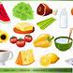
Proposed High School Menu
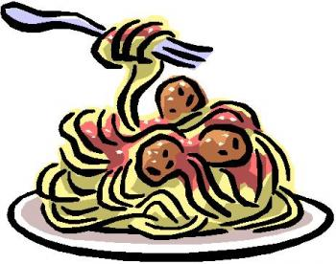
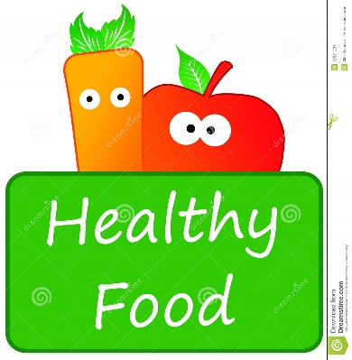
All meals are $6.50 and includes a milk

 | Monday | Tuesday | Wednesday | Thursday | Friday
Sept 14-18  Sept 28-Oct 2  Oct 13-16  Oct 26-30  Nov 9-13  Nov 23-27  Dec 7-11 | Lasagna with garlic toast | BBQ chicken with rice and vegetables | Taco Bake with rice | Chicken Fettuccine with garlic toast | Pizza and garlic fingers
Sept 21-25  Oct 5-9  Oct 19-23  Nov 2-6  Nov 16-19  Nov 30-Dec 3  Dec 14-18 | Spaghetti with meat sauce and garlic toast | Sloppy Joe with potatoes and vegetables | Pizza casserole with garlic toast | Sheppard pie with vegetables | Pizza and garlic fingers
Daily grabs | Sandwich - $3.50 Hamburger - $3.75 Wraps - $3.50  Sub - $3.50 Cheeseburger - $4.25 Chicken Burger - $3.75
Snacks | Muffin - $1.50 Water - $1.00  White milk - $0.55 Chocolate milk - $0.60 Cookie - $0.75

