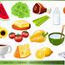
Proposed High School Menu
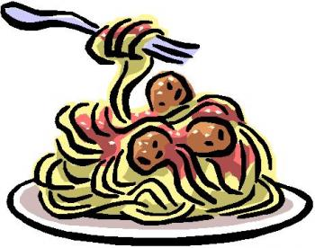
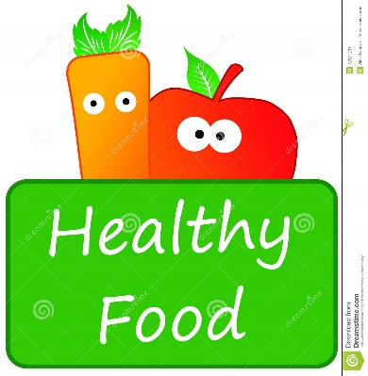
All meals are $6.50 and includes a milk

 | Monday | Tuesday | Wednesday | Thursday | Friday
Week 1  Sept 16-20  Sept 30-Oct 4  Oct 15-18  Oct 28-Nov 1  Nov 12-15  Nov 25-29  Dec 9-13 | Lasagna with garlic toast | BBQ chicken with rice and vegetables | Taco Bake with rice | Chicken Fettuccine with garlic toast | Pizza and garlic fingers
Week 2  Sept 23-27  Oct 7-11  Oct 21-25  Nov 4-7  Nov 18-21  Dec 2-6  Dec 16-20 | Spaghetti with meat sauce and garlic toast | Sloppy Joe with potatoes and vegetables | Pizza casserole with garlic toast | Sheppard pie with vegetables | Pizza and garlic fingers
Daily grabs | Sandwich - $3.50 Hamburger - $3.75 Wraps - $3.50  Sub - $3.50 Cheeseburger - $4.25 Chicken Burger - $3.75
Snacks | Muffin - $1.50 Water - $1.00  White milk - $0.55 Chocolate milk - $0.60 Cookie - $0.75

