Teams Mini Lesson:
How to Attach a File in an Assignment
Hi Everyone, I was going to demonstrate this in class, but since that isn’t an option, I am going to write out the step by step instructions on how to do it. When you are absolutely positive that your story is finished, has no errors, and is the absolute best story you can create; please follow the steps CAREFULLY to turn it in. I can’t wait to read what you have created. 😊
Step by step process:
1- Go to assignment tab.
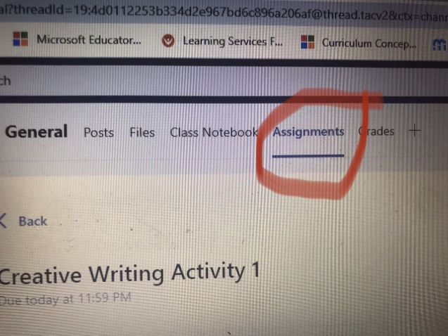

2- Open assignment by clicking on the assignment description.
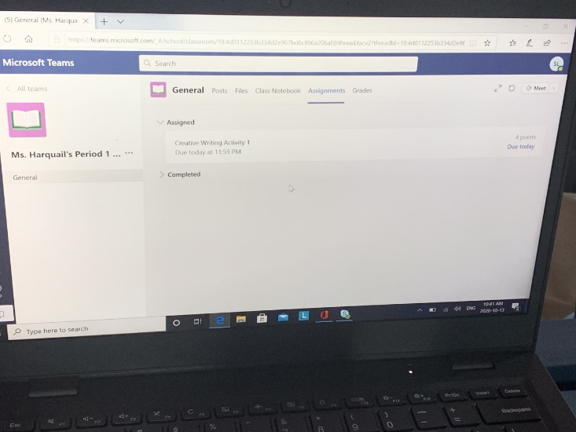
3- At the bottom of the left-hand side you will see a tab that says “my work”.
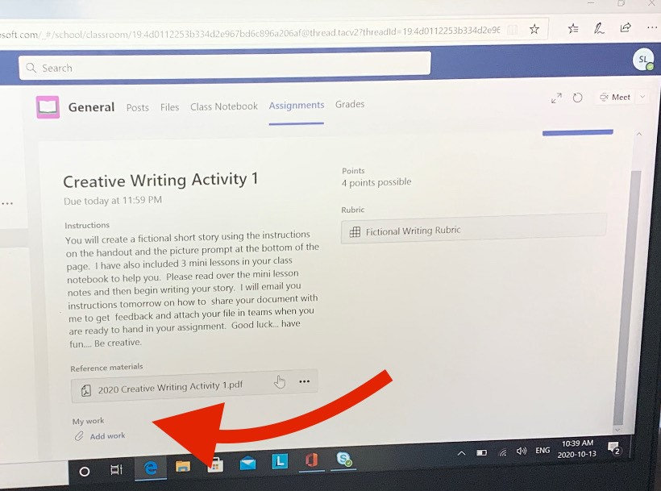

4- Under neath that, there is an option to add your work. You do this by clicking on the paper clip.
5- When you click the paper clip, you will automatically be taken to one drive.
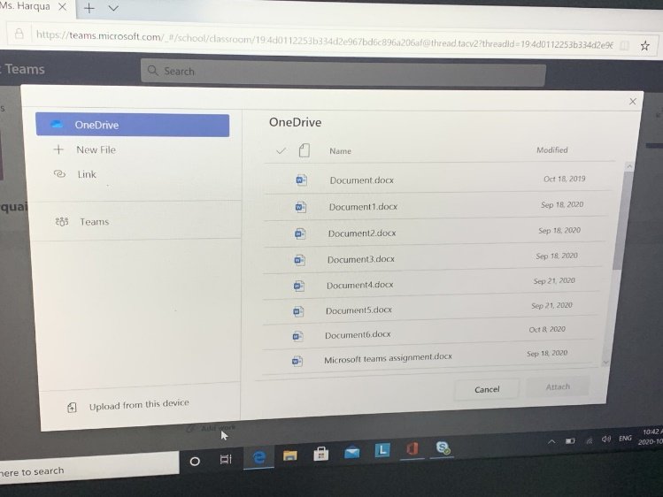
6- Find the assignment/ work / file you are trying to turn in and click on it.
7 – Once you click on the assignment, a check mark will appear before it and then you will select attach on the bottom right-hand side of the screen.
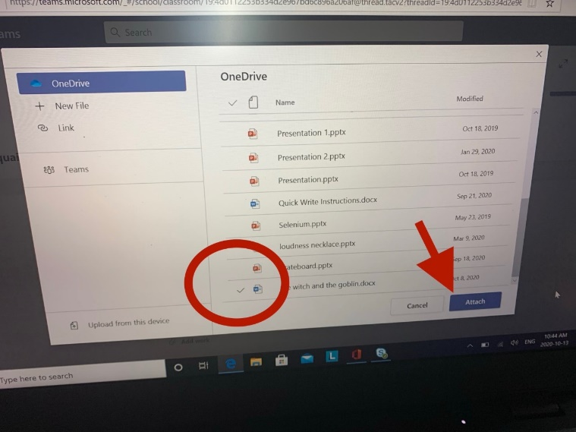
8- Once you click attach, you should see your assignment on the bottom of the page.
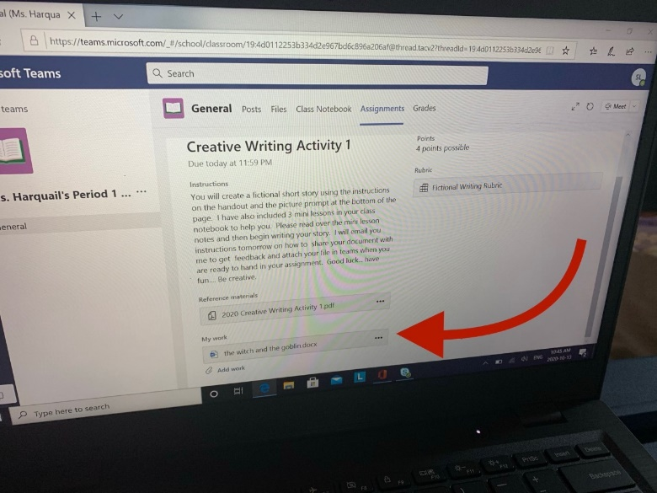
9 – Once you see the correct file, you can click turn in on the top right-hand corner of the screen.
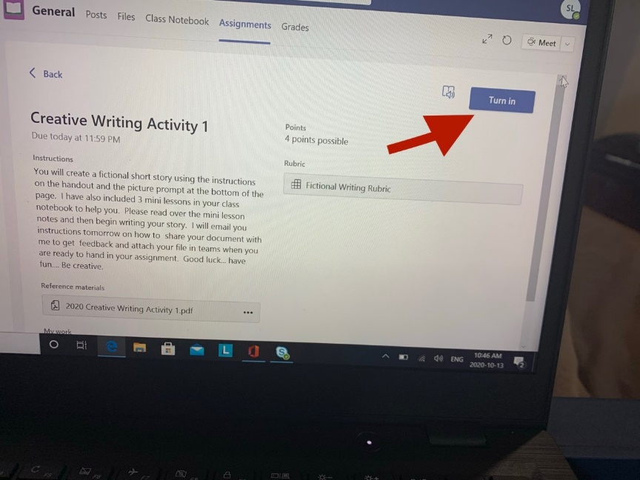

Important to remember: If you want to check it over one last time, you can simply click on your file and it will open directly in word. and you may make changes. After you have made the changes, select close on the top right-hand corner. This will take you back to the official turn in page.